Copper River Basin Regional Housing Authority Home Maintenance Guide

Contents

Common Items (Common Issues Throughout the Home) 4

Wall & Ceiling 4

Flooring 5

Baseboards 5

Window Hardware 6

Window Glass 7

Electrical Switches 8

Electrical Outlets 9

Light Fixtures 10

Smoke Detector 11

Interior Home 12

Kitchen 12

Electrical Outlets 12

Cabinets 13

Oven 14

Sink & Associated Plumbing 15

Range Hood Fan 18

Living Room 19

Backup Heater & Woodstove 19

Thermostat 20

Hallway 21

Bathroom 22

Door & Hardware 22

Toilet 24

Cabinet 26

Sink & Associated Plumbing 27

Medicine Cabinet or Mirror 30

Bathtub & Associated Plumbing 31

Towel Rack 34

Tissue Holder 35

Exhaust Fan 35

Bedrooms 36

Arctic Entry 37

Front Door 37

Second Door 39

Mechanical Room 39

Door & Hardware 39

Boiler 39

Hot Water Maker 42

Zone Valves & Thermostats 45

Expansion Tank 46

Glycol Systems 47

Circulation Pump 49

Boiler Temperature & Pressure 50

Pressure Relief Valve 50

Air Vents 51

Lift Pump 53

Aquastat Relay 53

High Limit & Cutoff Switch 55

Heat Recovery Ventilator 55

Fuel Storage Tank & Lines 58

Homes Without Municipal Water & Sewer 60

Exterior of Home 62

Porches & Railings 62

Exterior Lighting (Porch Lights) 63

Exterior GFCI Outlets 64

Foundation Out Of Level 65

Erosion & Damage 66

Electrical Ground Rods 67

Electrical Meter Base & Mast 69

Chimneys & Chimney Braces 71

Roofing 72

Walls & Siding 73

Eaves & Soffits 74

Rain Gutters 74

Arctic Boxes & Utilidors 75

Health & Safety 76

Bedbugs & Other Pests Detected 76

Municipal Water & Sewer 78

Electric Power 79

Electrical Wiring 80

Smoke Detectors 82

Fire Extinguisher 85

Heating System Safety 86

Egress (Fire Escapes) 86

Preventative Home Maintenance 88

3 to 6 Months 88

6 to 12 Months 89

Annually 90

Glossary of Terms 91

# Common Items (Common Issues Throughout the Home)

## Wall & Ceiling

* Patch hole in the sheetrock with sheetrock
  1. Prepare the area by cutting out the damage.
  2. Create patch matching the damaged area with a utility knife.
  3. Cut a piece of plywood to be narrower and longer than the hole.
  4. Screw plywood backing into place, such that it will reinforce the future sheetrock patch. All screws used should be slightly below flush with sheetrock.
  5. Place sheetrock patch into the hole, onto the plywood.
  6. Screw sheetrock patch into reinforcing plywood.
  7. Use putty knife to apply joint compound or spackling paste over the seams and screws. Use multiple coats until smooth and finish achieved.
  8. Sand until smooth and level.
  9. Video resource: <https://www.youtube.com/watch?v=nFluFrYTnyE>
* Patch hole in sheetrock with a patch

1. Prepare the area by cutting out the damage.
2. Apply joint compound or spackling paste to back of drywall patch.
3. Place sheetrock patch over the hole.
4. Use putty knife to apply joint compound or spackling paste. Smooth to flush finish.
5. Sand and finish until smooth and level.
6. Video resource: <https://www.youtube.com/watch?v=6WNMzFDIgb8>

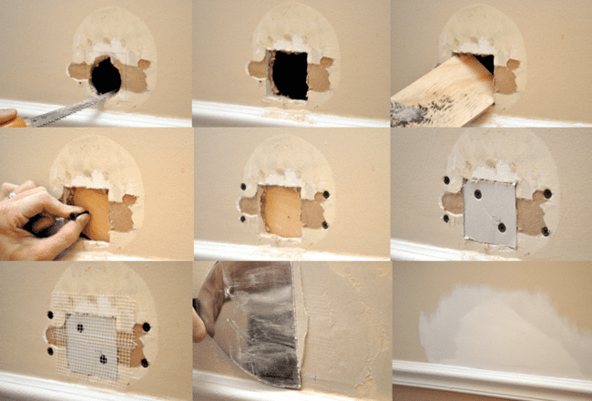

Figure 1: Sheetrock hole repair. Ethan. 1 June 2018. One Project Closer, How to Repair a Medium-Size Hole in Drywall, https://www.oneprojectcloser.com/how-to-repair-medium-size-hole-in-drywall/.

## Flooring

* Floor tile damaged
  1. Use grout knife to remove grout surrounding broken tile.
  2. Scor tile twice diagonally with ceramic tile saw blade, or scoring tool.
  3. Chisel out the broken pieces.
  4. Chisel out old tile mortar from floor.
  5. Apply new tile mortar to floor.
  6. Install new tile.
  7. Install new grout.
  8. Video resource: <https://www.youtube.com/watch?v=6fiZJknXcME>

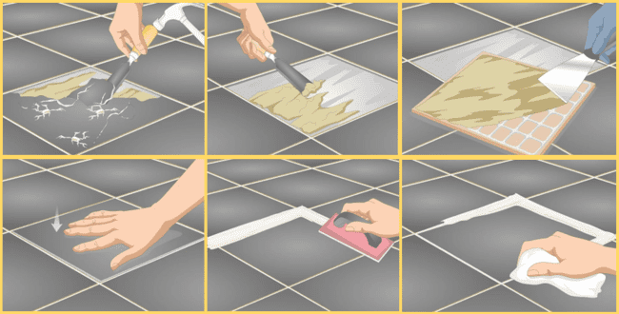

Figure 2: How to Repair Cracked Floor Tiles. Frickie, Art, and Eric McClure. How to Repair Cracked Floor Tiles, wikiHow, -6 June 2023, www.wikihow.com/Repair-Cracked-Floor-Tiles.

* Vinyl flooring seams coming apart
  1. Tape piece of scrap 2”x4” wood to the vinyl section with gap.
  2. Hammer the scrap wood piece in the direction of the gap.
  3. Video resource: <https://www.youtube.com/watch?v=B27CvpPkpck>

## Baseboards

* Baseboard heater damaged or covers falling off
  1. Repair: To the extent possible, baseboard heater cover metal can be cleaned and bent back into serviceable condition; attempt to clean and bend the metal back into the desired shape. If corroded and rusty, first clean, then sand, then prime, then paint.
  2. Replace:
     + Pull off ends caps.
     + Slide out face plates by pulling down or pressing up and pulling out.
     + Screw and pull out visible nails and screws.
     + Slide reciprocating saw blade (aka “Sawzall”) behind back panel, gently cut through screws to avoid wall damage.
     + Slide out damper vent.
     + Press and pop out holding brackets.
     + Rotate out remaining heater housing.
     + Replace in reverse order.
     + Video Content: <https://www.youtube.com/watch?v=QTNKHpRGy3E>

## Window Hardware

* Window will not open or close
  1. Check if window latch fully opened or close.
  2. Inspect window latch for damage, warping, cracking; if damaged, this must be replaced.
  3. Inspect the tracks for ice buildup: If tracks iced-up, it must be defrosted with heat gun, then dried with towels. To prevent interior ice build-up use drying solutions such as fans, dehumidifiers, or moisture absorbing bags.
  4. Inspect the tracks for debris: Check for dirt, debris, or sediment obstructing the sliding motion. If dirty, clean the tracks using a vacuum and/or solvent-dampened rag until they are free from dust and debris.
  5. Examine the rollers: Inspect the rollers on the bottom of the sash to ensure they are not damaged or broken. If the rollers are broken, they may need to be replaced.
  6. Lubricate the rollers with silicone-based lubricant. DO NOT use oil-based lubricants, as they attract dirt and debris.
  7. Lubricate the tracks: Apply a silicone-based lubricant to the tracks to reduce friction and help the window slide more easily. DO NOT use oil-based lubricants, as they attract dirt and debris.
  8. Inspect the weatherstripping: Check if the weatherstripping around the window is damaged or worn out. Damaged weatherstripping can interfere with the window’s operation. If necessary, replace the weatherstripping to ensure a proper seal.
  9. Video Content: <https://www.youtube.com/watch?v=r9Drg84wrWg>
* Window drafty
  1. Inspect the window: Check for any visible gaps, cracks, or damaged weatherstripping around the window frame and sash. Look for signs of air leakage or drafts when the window is closed.
  2. Apply weatherstripping: Replace or add new weatherstripping to seal any gaps between the window frame and sash. Self-stick vinyl foam weather seal can be used to fill large gaps. Measure the distance between the bottom of the window opening and the bottom of the raised sash, then cut the weatherstripping accordingly.
  3. Use draft stoppers: Place a draft stopper along the bottom of the window sill to prevent drafts from entering under the sash. You can purchase a draft stopper or make your own using materials like rice, lentils, or popcorn kernels.
  4. Seal cracks with nail polish: If you notice any small cracks in the window glass, you can temporarily seal them with clear nail polish. This can help reduce air infiltration until more permanent repairs are made.
  5. Consider window film: Applying thermal insulating film to the window glass can provide an additional layer of insulation and reduce drafts. Follow the manufacturer’s instructions for proper installation.
  6. Video Content: <https://www.youtube.com/watch?v=wHkQS5r1D1E>

## Window Glass

* Thermopane or double pane window seals blown (window foggy inside)
  1. Thermopane is a maker of glass windows; there are many window product manufacturers. Thermopane is not the only option for double-pane windows.
  2. Inspect window for seal gaps against exterior glass.
  3. Where seal is broken, dry off exterior with leaf blower or heat gun.
  4. Warm interior glass pane with heat gun or hair drier to vaporize remaining interior moisture.
  5. Re-seal broken exterior seal with waterproof, UV resistant silicone.
  6. Video content: <https://www.youtube.com/watch?v=S9cGT2jGiSY>
* One pane broken
  1. Inspect window glass for cracks.
  2. Cracks can be temporarily sealed with Window Repair Kit or clear nail polish.
  3. If desired, replace an individual panes by following manufacturers disassembly instructions.
  4. If no viable repair or replacement solution is immediately feasible, cover the window with insulation and plywood to prevent further damage and reduce utilities waste.
  5. Video content: <https://www.youtube.com/watch?v=57QPkOjHKY8>
* Two panes broken or boarded up
  1. Remove the old window.
  2. Measure the window, record measurements for new window purchase.
  3. Remove the window sash: Open the window and remove the sash by unscrewing or prying off the hinges or clips. If the window is painted shut, use a utility knife to cut through the paint along the edges of the sash.
  4. Remove the window frame: Use a pry bar to remove the window frame from the opening. If the frame is nailed in place, use a hammer to remove the nails. If it’s caulked, use a utility knife to cut through the caulk.
  5. Clean up: Remove any remaining debris or adhesive from the opening using a scraper or putty knife. Clean up any dust or dirt using a vacuum or damp cloth.
  6. Install the new window.
  7. Prepare the opening: Measure the rough opening and ensure it is square and level. Remove any existing window or frame, and clean the opening thoroughly.
  8. Apply flashing and sealant: Install a weather-resistant barrier, such as house wrap, around the opening. Apply flashing tape to the sill and sides of the opening to prevent water infiltration. Apply a bead of silicone caulk around the perimeter of the opening to create an airtight seal.
  9. Insert the window: Carefully place the new window into the opening, ensuring it is centered and level. Use shims to adjust and secure the window in place. Check for proper operation by opening and closing the sashes.
  10. Secure the window: Secure the window by driving screws or nails through the pre-drilled holes in the frame. Be careful not to overtighten, as this may distort the frame or glass.
  11. Insulate and finish: Insulate around the window frame using expanding foam insulation to fill any gaps between the window and rough opening. Trim any excess foam once it has cured. Install interior trim or casing around the window to provide a finished appearance.
  12. If no viable replacement solution immediately feasible, cover the broken window with insulation and plywood to prevent further damage and reduce utilities waste.
  13. Video content: <https://www.youtube.com/watch?v=rHVYqMRnr94>

## Electrical Switches

* Switch plate cover missing
  1. Turn off the power: Turn off the power to the light switch at the main circuit breaker box.
  2. Remove the cover plate: Use a flat-bladed screwdriver to remove the cover plate from the light switch.
  3. Remove the old switch plate: Unscrew the screws holding the old switch plate in place.
  4. Install the new switch plate: Place the new switch plate over the light switch and screw it in place using the screws provided.
  5. Turn on the power: Turn on the power to the light switch at the main circuit breaker box.
  6. Video content: <https://www.youtube.com/watch?v=vR0NhOivYGA>
* Troubleshoot light switch not working
  1. Check if multiple lights are affected or if other switches control the same lights.
  2. Look for signs of damage like burning smell or discolored switch.
  3. Replace light bulb if only one light not working. Ensure bulb is screwed in properly.
  4. Check circuit breaker panel for any tripped breakers and reset to ON position.
  5. Turn off power to switch at main breaker box.
  6. Remove switch cover plate. Inspect for loose wires or damage.
  7. Use a voltage tester to check for power at switch when turned ON.
  8. If no power at switch, consider replacing the light switch.
  9. Video content: <https://www.youtube.com/watch?v=6qejXNvPows>
* Replace non-working light switch
  1. Turn off the power: Turn off the power to the light switch at the main circuit breaker box.
  2. Remove the switch cover plate: Use a flat-bladed screwdriver to remove the cover plate from the light switch.
  3. Remove the old switch: Unscrew the screws holding the old switch in place.
  4. Disconnect the wires: Carefully disconnect the wires from the old switch by unscrewing the terminal screws.
  5. Connect the new switch: Connect the wires to the corresponding terminals on the new switch and tighten the terminal screws.
  6. Secure the new switch: Attach the new switch to the electrical box using the screws provided.
  7. Install the switch cover plate: Place the cover plate over the new switch and screw it in place.
  8. Turn on the power: Turn on the power to the light switch at the main circuit breaker box.
  9. Video content: <https://www.youtube.com/watch?v=vx-VEq7-Rv4>

## Electrical Outlets

* Outlets not working
  1. Check the Circuit Breaker: Start by checking the circuit breaker to ensure it hasn’t tripped. Locate the breaker panel in your home and look for any breakers that are in the “off” position. If you find one, switch it back on and test the outlet again. If breaker flips “off” again with different devices plugged in, test to see which devices the circuit can handle before overloading. In the future, try using fewer devices.
  2. Test with a Different Device: Plug a different device into the outlet to determine if the problem lies with the device or the outlet itself. If the new device works, then the original device may be faulty.
  3. Inspect the Outlet: Visually inspect the outlet for any visible damage, such as burn marks, loose wires, corrosion. Remove debris obstructing contacts. Verify the wiring is correct, undamaged. Test for electrical flow with multimeter.
  4. Reset GFCI Outlets: Ground Fault Circuit Interrupter (GFCI) outlets are designed to protect against electrical shock. Look for any GFCI outlets in your home, such as those found in bathrooms or kitchens, and press the “reset” button if it has been tripped. Reset GFCI outlets near the non-working outlet – the issue may be related.
  5. Check for Loose Wires: Turn off the power to the outlet at the circuit breaker and carefully remove the outlet cover plate. Inspect the wiring connections to ensure they are secure. If you find any loose wires, tighten them using a screwdriver.
  6. Video resource: <https://www.youtube.com/watch?v=GETyRTWUOSk>
* Safety hazard or sparking sound
  1. Immediately flip the circuit breaker for that outlet to the OFF position to cut power.
  2. Visually inspect the outlet for damage. Look for scorch marks, melted plastic, or exposed wires.
  3. Unplug all devices from the outlet and do not use it.
  4. Check outlet with a voltage tester to confirm power is off before touching.
  5. Remove the outlet cover and check connections. Make sure wires are secured properly.
  6. Check for loose, damaged, or burnt wire connections. Rewire any loose connections.
  7. If wires are damaged, the outlet must be replaced. Consult an electrician if unsure.
  8. Replace the outlet if there are burn marks or the plastic appears melted or damaged.
  9. Confirm no wires are pinched or improperly connected when installing new outlet.
  10. Restore power once the outlet has been replaced and carefully check for sparks.
  11. If the issue persists, disable the circuit and contact a licensed electrician immediately.
  12. Video content: <https://www.youtube.com/watch?v=RO6Kq65HwNw&t=12s>

## Light Fixtures

* Fluorescent light fixture with ballasts (uncommon)
  1. Check the power supply: Ensure that the light fixture is receiving power.
  2. Check the circuit breaker or fuse box to make sure the circuit is not tripped or the fuse is not blown.
  3. Inspect the tubes: Examine the fluorescent tubes for any signs of damage or discoloration. If a tube is blackened at the ends or has a dark line running along it, it may be faulty and need replacement. Replace with the same tube model.
  4. Verify wiring connections: Ensure that all wiring connections within the fixture are secure and properly connected to the ballast.
  5. Inspect other components: Examine other components of the light fixture, such as sockets and lamp holders, for any signs of damage or malfunction.
  6. Check for voltage fluctuations at the outlet with a multimeter.
  7. Test with a different ballast: If you have access to a spare ballast, try replacing the existing one to see if that resolves the problem.
  8. Replace ballast if suspected faulty: Turn off breaker switch associated to light fixture. Remove the cover to expose the internal wiring and ballast. Take photo to document wiring configuration. Disconnect all the wires connected to the old ballast. Unscrew and remove the mounting nut(s) holding the old ballast in place. Mount the new ballast and wiring.
  9. If still defective, possibly replace the starter.
  10. If still defective, consult a professional.
  11. Video content: <https://www.youtube.com/watch?v=aWvREr_qJTM>
* Replace light bulbs
  1. A non-functioning lightbulb may not turn on due to a broken filament, loose/corroded socket connections, faulty wiring, tripped breaker, or simply needing replacement after expiring rated hours of use.
  2. Turn off light, allow bulb to cool.
  3. Wear gloves for safety and grip.
  4. Check old bulb type and wattage.
  5. Unscrew old bulb counterclockwise.
  6. Inspect, clean socket.
  7. Align new bulb, insert firmly twisting clockwise.
  8. Test new bulb by turning on switch.
  9. Discard old bulb properly.
  10. Label replacement date if accessible.
  11. Video content: <https://www.youtube.com/watch?v=P5_2mxvkZ0o>
* Fixture not working
  1. Check if the light bulb is burnt out or not tightly screwed into the socket.
  2. Test with a different bulb to determine if the issue lies with the bulb type itself.
  3. Inspect wiring for loose or damaged wires in the fixture and ensure securely connected.
  4. Test the switch to ensure toggling on and off correctly. If faulty, replace the switch unit.
  5. Check the circuit breaker to ensure light fixture has not tripped. If tripped, this indicates the power draw of fixtures and devices drawing on that circuit is overloading that circuit. Use less devices, or consult an electrician to install a new circuit.
  6. Examine the wiring connections within fixture to ensure secure. If not, tighten or resolve faulty wiring connection.
  7. Look for a faulty socket within the light fixture. If faulty, will need replacing.
  8. Consider a dimmer switch to reduce power draw on the associate circuit breaker.
  9. Inspect other components: Check other components of the fixture, such as sockets and wiring, for any signs of damage or malfunction.
  10. If still faulty, consider consulting a professional electrician.
  11. Video content: <https://www.youtube.com/watch?v=iSiaxWJ0veI>

## Smoke Detector

* Replace batteries
  1. If smoke detector wired into home electrical, turn off the associated breaker power before starting any electrical work.
  2. Remove the cover to expose the battery compartment.
  3. Remove the old battery.
  4. Install the new battery, making sure that it is properly aligned with the positive and negative terminals.
  5. Replace the cover, ensure that it is securely fastened.
  6. Test the smoke detector by holding down the test button and ensure it chirps.
  7. Video content: <https://www.youtube.com/watch?v=C9iKopZ2NeU>
* Will not stop beeping even after battery is changed
  1. Do not use an old battery.
  2. The new battery might be faulty – test with a different new battery.
  3. Device Doesn’t Recognize the New Battery: You can try waiting for the device to recognize the new battery, or perform a hard reset to clear its memory.
  4. Dust Blocking the Detector’s Sensors: Dust can accumulate on the sensors of a smoke detector, causing them to trigger false alarms. Wiping the sensors clean can help resolve this issue.
  5. Corrosion and Leaked Chemicals: Over time, batteries can leak and create a flaky residue that interferes with battery connections. Cleaning the contacts and replacing corroded batteries can help resolve this issue.
  6. Video content: <https://www.youtube.com/watch?v=FakT1rgcmrw>
* Goes off all the time
  1. Turn on hood fan when cooking to carry away smoke and steam.
  2. Open windows.
  3. Place fan near kitchen to blow fumes away from smoke detector.
  4. Don’t burn food when cooking.
  5. Install smoke alarm slightly further from the kitchen.
  6. Replace batteries, ensure properly connected.
  7. Gently clean with soft brush or compressed air.
  8. Press test button to check function.
  9. Check for humidity, drafts, extreme temps.
  10. Inspect for insects, remove if found.
  11. Replace if over 10 years old.
  12. Check wiring is secure, undamaged if hardwired.
  13. Review manufacturer instructions.
  14. Consult electrician or support if issues persist.
  15. Video content: <https://www.youtube.com/watch?v=14yps71nnt8>

# Interior Home

## Kitchen

### Electrical Outlets

* Kitchen GFCI Outlets not working
  1. Press the "Reset" button on the GFCI outlet firmly. Listen for a click.
  2. Confirm the "Test" button trips the outlet when pressed. Press "Reset" again after testing.
  3. Check if other outlets downstream have lost power. GFCI may have tripped and needs resetting.
  4. Plug a lamp into the outlet to check if power is restored. Try other devices if needed.
  5. Inspect the outlet wires for any loose, damaged, or incorrect connections. Rewire properly.
  6. Test outlet with a multimeter. Verify correct voltage. If not, issue may be wiring.
  7. Replace GFCI outlet if it fails the self-test, won't reset, or has physical damage.
  8. Ensure ground wire is connected properly when installing replacement GFCI.
  9. Check circuit breaker powering the GFCI and reset it fully if needed.
  10. Hire an electrician if outlet won't work after replacements and breaker resets.
  11. Video content: <https://www.youtube.com/watch?v=CpCoOoTRIQ0>

### Cabinets

* Cabinet doors damaged or fallen off
  1. Identify the type of hinge - common types are butterfly, concealed, or European style. This determines how to adjust them.
  2. Check if hinge screws are loose and tighten with a screwdriver if so. Don't overtighten, or wood holes could be stripped.
  3. Clean hinge joints with a damp cloth to remove any debris or grease buildup.
  4. Apply a lubricant like WD-40 or silicone spray to the hinge joint if squeaky.
  5. Adjust cabinet door alignment by loosening hinge screws slightly and repositioning door.
  6. Shim hinges with thin washers if the door is sagging or unaligned with the cabinet face.
  7. Replace damaged or worn out hinges. Use same size and style hinge for replacement.
  8. Update old hinges to soft-close dampers to prevent slamming and damage.
  9. Ensure doors are hanging flat by adjusting lateral hinge screws if present.
  10. Align hinge plates so door closes cleanly against cabinet frame without gaps.
  11. Video content: <https://www.youtube.com/watch?v=DI_9rozp_Mc>
* Drawer fronts missing
  1. Purchase a new cabinet drawer of the same size.
  2. For a cheap fix, cut a piece of plywood or scrap wood to the same size as the old door.
  3. Screw the piece of wood onto the sliding portion.
  4. Video content: <https://www.youtube.com/watch?v=8X0VxVh_7Is>
* Water damage under the sink
  1. Turn off water supply lines and drain any standing water under sink.
  2. Remove all items from under sink and use towels to soak up excess water.
  3. Check for and repair any leaks from pipes, drain lines, or the faucet.
  4. Use fans and dehumidifier to fully dry area over 2-3 days.
  5. Unscrew, drain and clean the P-trap with a catch bucket. Clogged P-trap can exacerbate leaking plumbing. Renew PTFE tape in other plumbing joints in the problem area.
  6. Clean surfaces with hot soapy water and disinfectants if mold is present.
  7. Seal any cracks in sink basin using caulk to prevent leakage.
  8. Replace any water damaged cabinets, drawers, or flooring as needed.
  9. Install leak detection devices that shut off water if leak is detected.
  10. Routinely inspect under sink for any leaks, cracks, or moisture buildup.
  11. Keep sink cabinet clutter free and do not store any items directly on floor.
  12. Video content: <https://www.youtube.com/watch?v=Q5le2ZFCQjM>
* Laminate countertop damaged
  1. Clean the damaged area thoroughly and sand lightly to roughen surface.
  2. Fill small holes or chips with a laminate repair filler compound or caulk and allow to fully harden.
  3. If the damage exposes the substrate, apply laminate patches and adhesive to bond to the countertop.
  4. For edge damage, use a file to shape the laminate for bonding a new matching laminate strip.
  5. Remove any burrs or rough edges using a sanding block and buff repaired area.
  6. Use touch-up markers or laminate repair pens to blend color and pattern. Allow to dry fully.
  7. Renew the glossy finish using a laminate polish or a gentle buffing with steel wool.
  8. Avoid placing hot pans directly on the repaired section to prevent future damage.
  9. Video content: <https://www.youtube.com/watch?v=r27oBVmLTN4>

### Oven

* Oven burners not working (blown elements)
  1. Unplug the stove or turn off the breaker supplying power to it.
  2. Remove the burner grate and lift out the burner head and cap.
  3. Inspect the igniter and element for any visible damage, cracks, or separated coils.
  4. Use an ohmmeter to check element for continuity. No continuity means it needs replacing.
  5. Make sure burner sockets are clean and dry before installing new elements.
  6. Clip the new replacement element wires into the terminal blocks.
  7. Reassemble the burner cap, head, and grate. Ensure they are seated properly.
  8. Restore power and test burner function on all settings.
  9. Check that the new element glows red when on and contact is even.
  10. Contact manufacturer if replacement element still does not heat despite having continuity.
  11. Video content: <https://www.youtube.com/watch?v=UCVPltPsyfs>
* Oven not working (blown element)
  1. Check the circuit breaker and reset if tripped. Verify oven is getting power.
  2. Open the oven door and visually inspect baking and broiling elements for any damage.
  3. Use a multimeter to check for continuity in each element. No continuity means it's blown.
  4. Unplug oven or turn off power at breaker. Remove interior oven racks.
  5. Locate element mounting screws and wiring. Unscrew element and pull out.
  6. Attach the new replacement element, matching the wiring colors. Secure mounting screws.
  7. Reinstall oven racks and any interior reflector pans.
  8. Restore power and test oven function in bake and broil modes. Preheat oven first.
  9. If oven still doesn't heat, check temperature sensor and thermostat for issues.
  10. Contact manufacturer if new element gets power but doesn't heat oven cavity.
  11. Video content: <https://www.youtube.com/watch?v=8jyrEDWtsvI>

### 

### Sink & Associated Plumbing

* Faucet not working
  1. Check under sink for any leaking pipes or loose connections and tighten as needed.
  2. Turn off hot and cold water supply lines to faucet and turn faucet on to relieve pressure.
  3. Disassemble faucet handle and cap to access cartridge or valve. Check for debris.
  4. Remove cartridge/valve and inspect washers, O-rings, seals for damage. Replace as needed.
  5. Scrub interior faucet parts with vinegar and water to remove mineral buildup.
  6. Replace cartridge/valve and reinstall handle components. Be sure parts are aligned.
  7. Turn on water supply and check for leaks. Tighten connections if leaking persists.
  8. Take faucet apart and reposition any incorrectly seated washers, seals or cartridge.
  9. Remove faucet aerators and filters and clean out any accumulated sediment.
  10. Replace faucet if repair parts no longer available or issues persist.
  11. Video content: <https://www.youtube.com/watch?v=rcV6CwoKwGg>

Figure 3: Anatomy of a kitchen sink. Yoshitani, Yoshi. “Anatomy of a Kitchen Sink.” Tumblr, 8 Aug. 2020, yoshiyoshitani.tumblr.com/post/629752210765594625/anatomy-of-a-kitchen-sink.

* Sprayer not working
  1. Check if sprayer is getting adequate water flow and pressure. Turn on faucet fully.
  2. Disconnect sprayer hose under sink and inspect hose/fittings for cracks or loose connections.
  3. Clean sprayer nozzle openings thoroughly as they can get clogged with debris and mineral deposits.
  4. Disassemble sprayer handle and check for worn washers, valves, or O-rings. Replace as needed.
  5. Check divertor valve under sink where hose connects. Clean or replace internal components if faulty.
  6. Flush hot water through sprayer hose to remove any debris.
  7. Reassemble sprayer handle ensuring sealing components are seated correctly.
  8. Reconnect sprayer hose to faucet diverter valve under sink. Confirm fittings are tight.
  9. Turn on faucet and test sprayer on all settings. Check for leaks.
  10. Replace sprayer hose or entire faucet sprayer assembly if issues persist.
  11. Video content: <https://www.youtube.com/watch?v=MvCF3wtJFhM>
* Drain clogged
  1. Try plunging the drain first to clear any clogs. Cover overflow holes fully when plunging.
  2. Use a zip-it style drain cleaner to pull hair and debris from drain pipe.
  3. Check pipes under sink for leaks and tighten any loose slip joints or connections.
  4. Take apart the P-trap and clean out any built up gunk or clogs.
  5. Dump baking soda and vinegar down the drain, let sit 30 mins, then rinse with hot water.
  6. Use a drain snake or auger if drain is still backed up. Take care not to scratch porcelain.
  7. Remove pop-up sink stopper and clean built-up debris from mechanisms.
  8. If necessary, remove entire P-trap assembly and replace corroded or damaged parts.
  9. Check sink strainer/basket for debris blocking water flow and remove if needed.
  10. Hire a plumber if significant blockages persist or pipes under sink need replacement.
  11. Video content: <https://www.youtube.com/watch?v=n3kVpCEsOqA>
* Plumbing under the sink clogged
  1. Try plunging the drain first to clear any clogs. Cover overflow holes fully when plunging.
  2. Use a zip-it style drain cleaner to pull hair and debris from drain pipe.
  3. Check pipes under sink for leaks and tighten any loose slip joints or connections.
  4. Take apart the P-trap and clean out any built up gunk or clogs.
  5. Dump baking soda and vinegar down the drain, let sit 30 mins, then rinse with hot water.
  6. Use a drain snake or auger if drain is still backed up. Take care not to scratch porcelain.
  7. Remove pop-up sink stopper and clean built-up debris from mechanisms.
  8. If necessary, remove entire P-trap assembly and replace corroded or damaged parts.
  9. Check sink strainer/basket for debris blocking water flow and remove if needed.
  10. Hire a plumber if significant blockages persist or pipes under sink need replacement.
  11. Video content: <https://www.youtube.com/watch?v=T_QJf3TKvLM>

Figure 4: How to Unclog a Sink Drain in the Kitchen and Elsewhere, Constellation, 28 Mar. 2022, blog.constellation.com/2017/07/14/clogged-drains/.

### Range Hood Fan

* Not working
  1. Check if the fan is getting power by turning it on at the switch or control panel.
  2. Inspect the fan blades for any blockages or debris that could impede spinning.
  3. Clean the metal grease filter in the dishwasher or soak in degreaser if very dirty.
  4. Remove the housing cover and check if wiring connections are secure or if any are detached.
  5. Test the voltage to the fan while switched on. If low, problem could be electrical.
  6. Replace the fan capacitor if fan hums but doesn't spin. Test capacitor first.
  7. Lubricate fan motor bearings with penetrating oil if motor is working but sluggish.
  8. Look for cracks or damage to fan blades. Replace blades or entire fan unit if needed.
  9. Check ducting for tightness of joints and any punctures or restrictions.
  10. Replace range hood if cleaning and repairs do not restore adequate airflow.
  11. Video content: <https://www.youtube.com/watch?v=veJhk6hWb2c>
* Noisy
  1. Remove any debris that may be stuck in the fan blades causing imbalance.
  2. Inspect mounting brackets and ducting to ensure hood is securely installed. Tighten if loose.
  3. Clean fan motor of any accumulated grease and lint. Lubricate bearings if squeaky.
  4. Check fan blades for any warps or damage causing excess friction. Replace if needed.
  5. Look for contact between fan blades and housing that can cause vibration. Adjust alignment.
  6. Replace worn out fan motor bearings. Bearings gone bad can emit loud noises.
  7. Upgrade to quieter fan blades, like nylon instead of cheaper plastic models.
  8. Add sound damping insulation inside the hood and along the ducting path.
  9. Use vibration-absorbing mounting pads instead of metal-to-metal contact.
  10. If excessive noise persists, best option may be replacing the entire fan unit.
  11. Video content: <https://www.youtube.com/watch?v=RqGmiV1A7mk>

## Living Room

### Backup Heater & Woodstove

* Backup Heater or Woodstove not working
  1. Check that the flue is clear of any blockages like bird nests or leaves that would restrict airflow.
  2. Inspect door seals and gaskets for any air leaks allowing smoke to escape - replace any worn out seals.
  3. Make sure the log size is appropriate - logs that are too big can smother the flames. Split them smaller if needed.
  4. Ensure seasoned, dry wood is being used - wet wood leads to smoky, inefficient fires.
  5. Open the air intake damper fully to allow enough oxygen into the firebox.
  6. Clean soot buildup off the glass door and internal stove walls which can inhibit heat transfer.
  7. Remove excess ash buildup by gently sweeping it from under the grate into a metal container.
  8. Check the catalytic combustor and clean it if equipped - helps burn smoke and gases.
  9. Make sure baffle panels and interior bricks are properly positioned to maintain air flow.
  10. Have a professional inspect and clean the chimney annually or if excessive creosote builds up.
  11. Video content: <https://www.youtube.com/watch?v=DckxTNAAQck>
* Backup Heater or Woodstove not venting properly
  1. Only burn recommended fuels like seasoned hardwoods, or manufacturer recommended fuel pellets, and not trash or plastics.
  2. Check that seasoned, dry wood is being burned, not green or wet wood. Wet wood causes more smoke.
  3. Adjust wood load to prevent overstuffing the firebox which restricts airflow.
  4. Clear out excess ashes from under the grate to improve air circulation.
  5. Open the damper fully and allow the fire to get hotter before adjusting it down.
  6. Make sure the air intake vents are fully open to allow oxygen for combustion.
  7. Inspect the flume pipe and chimney for any blockages like bird nests that restrict airflow.
  8. Check the door gasket for proper sealing, replace if worn out.
  9. Clean the catalytic combustor regularly if equipped to burn smoke.
  10. Have the chimney and flume professionally cleaned annually.
  11. Video content: <https://www.youtube.com/watch?v=rqL3ffiJ6j0>

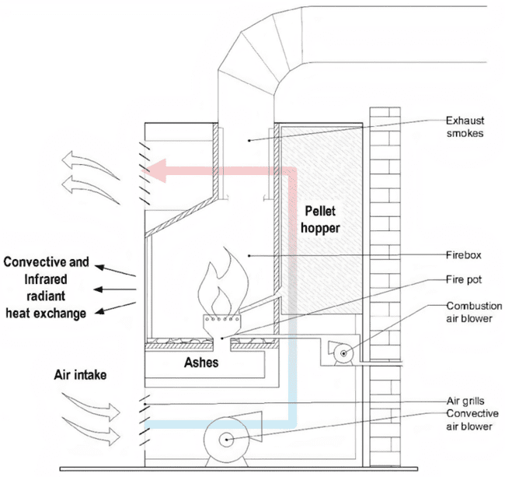

Figure 5: Common design of a pellet burning stove. Marigo, et al. Energy Analysis of a Wood or Pellet Stove in a Single-Family House Equipped with Gas Boiler and Radiators, https://doi.org/10.1007/s12273-022-0884-1.

### Thermostat

* Heat will not turn on
  1. Check the thermostat settings and verify the temperature is set higher than the current room temperature.
  2. Inspect the air filter and replace it if dirty. Dirty filters can block airflow.
  3. Check the circuit breaker and reset if tripped. Verify power is going to the HVAC system.
  4. Examine the condenser unit outside and clear any debris blocking airflow through the coils.
  5. Inspect the blower fan and motor and ensure the fan spins freely. Oil it if needed.
  6. Check the pilot light if it's a gas furnace. Relight it if needed and test the gas valve.
  7. Look for frost buildup on the coils indicating low refrigerant. Contact an HVAC pro to recharge it.
  8. Make sure vents and ducts are open and unobstructed throughout the house.
  9. Inspect the flame sensor and thermocouple on a gas furnace and clean with steel wool.
  10. Schedule an HVAC professional to examine the system if issues persist after basic troubleshooting.
  11. Video content: <https://www.youtube.com/watch?v=sRvH-io-ZtA>
* Heat will not turn off
  1. Check the thermostat and lower the temperature setting below the current room temperature.
  2. Inspect the thermostat wiring to make sure no wires are loose or disconnected.
  3. Clean the thermostat contacts with electrical contact cleaner spray to ensure a proper connection.
  4. Test the thermostat by disconnecting it from the HVAC system. If it still runs, the thermostat is defective.
  5. Inspect the contactor relay - if stuck closed, it will allow continuous operation. Replace if faulty.
  6. Make sure the delays on the heating cycle are programmed correctly and not set too short. Adjust as needed.
  7. Check if limit switches are functioning properly and cutting off operation at the right temperatures.
  8. Examine the heat anticipator and adjust setting to match the amp draw of the heating system.
  9. Make sure the blower fan shuts off after the heating cycle ends. If not, fan control may be faulty.
  10. Call an HVAC technician if basic troubleshooting does not reveal the issue. May require control board diagnosis.
  11. Video content: <https://www.youtube.com/watch?v=rEdeiincEN0>

## Hallway

* Hallway Stairs or Railings (Diomede Only) loose or shaking
  1. Check where the railing connects to the wall and newel posts for any loose screws, bolts, or nails. Tighten if found loose.
  2. Look for any broken welds, joints, or connectors causing the railing to shift and repair as needed.
  3. Check the balusters for any loose connections and re-secure to the rail and treads as required.
  4. Examine areas where spindles meet railing for gaps caused by wear. Refasten or shim with washers.
  5. Determine if railing movement is from wall or newel post issues. Tighten connections or re-anchor to floor/ceiling.
  6. For wooden railings, a loose tenon joint may need glue reapplied. Clamp until dry.
  7. Fill any newel post holes that have become enlarged with shims before re-securing with adhesive.
  8. Replace corroded railing anchors or supports, especially for exterior applications.
  9. Add decorative brackets underneath stair treads for intermediate support if needed.
  10. If the issues persist, full railing replacement may be required if unsafe.
  11. Video content: <https://www.youtube.com/watch?v=JEiJeuKuN2Y>
* Stairs or Railings (Diomede Only) scratches
  1. Clean the scratched area thoroughly and sand lightly to roughness and remove any loose paint.
  2. Apply painter's tape around the scratched section to protect surrounding paint. Cut tape to tightly fit edges.
  3. Fill any gouges in the wood with wood filler and let dry completely. Sand smooth.
  4. Apply two coats of high quality exterior or interior paint primer to the scratches, allowing drying in between.
  5. Once primer is fully dry, repaint scratches with two finish coats of topcoat paint matching your existing stair color. Allow proper drying between coats.
  6. Video content: <https://www.youtube.com/watch?v=KLAtLUR-R6g>

## Bathroom

* Common Items (no smoke detector, a few have windows)

### Door & Hardware

* Doorknob or latch not working
  1. Check that the door is aligned properly and not warped, binding the mechanism.
  2. Ensure the spindle and latch bolt can move freely and are lubricated. Use powdered graphite or spray lubricant.
  3. Remove knob and inspect interior components for wear, damage or loose parts. Replace any worn springs or pins.
  4. Verify the latch bolt is retracting fully when rotating knob. File edge if scraping against strike plate.
  5. Adjust strike plate placement if misaligned from latch bolt, causing binding.
  6. Tighten any loose interior component screws but do not overtighten.
  7. Clean out any accumulated dirt, debris or paint buildup inside mechanism.
  8. Replace knob/lever handles if interior components still do not move smoothly.
  9. Consider replacing entire lockset if significant internal damage and components are unserviceable.
  10. Call a locksmith for professional assessment if troubleshooting does not reveal cause.
  11. Video content: <https://www.youtube.com/watch?v=qG8CruM5zYk>

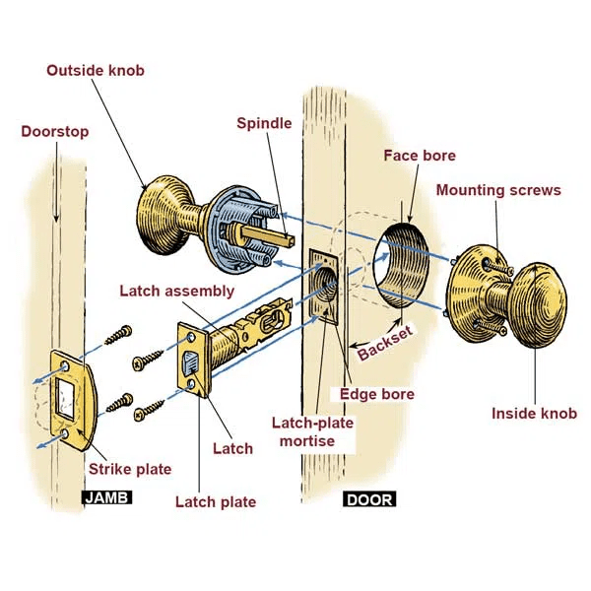

Figure 6: Common design of a doorknob and latch system. Gibson, Scott. “How to Install a Lockset.” This Old House, 2023, www.thisoldhouse.com/home-safety/21016489/how-to-install-a-lockset.

* Door falling off
  1. Inspect hinges for loose screws or misalignment and tighten screws or reposition hinges.
  2. Use plastic screw hole inserts to re-use old holes which have become stripped.
  3. Check for level and plumb door frame for settling. Shim or re-secure frame if out of alignment.
  4. Verify door size/thickness matches frame openings. Plane or sand door edges if required.
  5. Clean out dirty hinge mortises and fill gaps with wood shims to reduce play and sagging.
  6. Replace worn out or undersized hinges that allow the door to sag and lose structure.
  7. Adjust any misaligned strikes plates causing interference between door and frame.
  8. Check for swelling if door rubs frame at certain points - humidity or water exposure causes swelling.
  9. Sand or plane any high spots or warped sections on door that prevent even contact.
  10. Reset popping out nails or screws on door that leads to detachment and unevenness.
  11. Install additional support alongside frame like wall-mounted door braces for extra strength.
  12. Video content: <https://www.youtube.com/watch?v=ZcDj6g2UODw>

### Toilet

* Runs all the time
  1. Check that the flapper valve is sealing properly against the flush valve seal when closed. Adjust if needed.
  2. Make sure stopper seal is clean and clear of any debris or buildup preventing proper contact.
  3. Check fill valve float arm and adjust if set too high, allowing water to enter overflow tube.
  4. Inspect the chain connecting the flapper valve to the flush handle and adjust slack so it is not holding valve open.
  5. Examine fill valve for cracks or defects causing water to leak through. Replace fill valve if faulty.
  6. Remove toilet tank lid and inspect all gaskets and washers for cracks. Replace as needed.
  7. Consider replacing flapper valve and other internal components if toilet is older.
  8. Check that water supply line filler hose washer is in good shape and replace if worn out.
  9. Clear out debris from the siphon jet hole if partially blocked, preventing siphoning.
  10. Listen for hissing air leak in valving indicating bigger problem.
  11. Video content: <https://www.youtube.com/watch?v=UV-peiKW9gM>

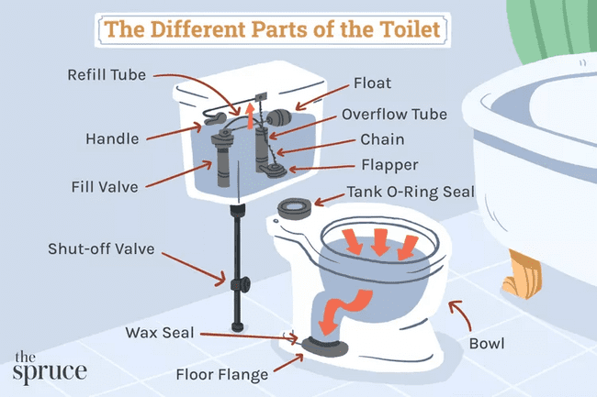

Figure 7: Parts of a toilet. Wallender, Lee. “Parts of a Toilet: What They Are and How to Fix Them.” The Spruce, 19 Oct. 2023, www.thespruce.com/the-parts-of-a-toilet-4145300.

* Leaking causing floor damage
  1. Inspect flooring for discoloration, swelling, mold, or rot to pinpoint affected areas. Probe with awl to check for sponginess.
  2. Remove any wet carpeting, underlayment, and floorboards to access subfloor. Dry out subfloor thoroughly.
  3. Check if subfloor is salvageable or needs replacement. Solid, unaffected areas can be kept.
  4. Use a moisture meter to test wood moisture content before installing new flooring. Wait until it matches surroundings.
  5. Cut away any rotted or moldy sections of subfloor and replace with matching plywood.
  6. Install new, matching floor joists or structural supports if needed.
  7. Replace insulation under the floor if it got soaked. Use mold resistant materials.
  8. Clean, sand, and primer subfloor prior to new flooring installation.
  9. Match flooring thickness of replacement boards or underlayment to existing.
  10. Refasten new floor following manufacturer’s directions. Nail/glue perimeter first then work inward.
  11. Video content: <https://www.youtube.com/watch?v=xqguFDE1wOo>
* Cannot flush
  1. Check for clogs - use a plunger to clear obstructions in trapway. Snaking may be required for major clog.
  2. Examine chain/handle assembly - adjusted too loose or disconnected can prevent flapper from lifting.
  3. Inspect flapper valve - cracked, warped, or misaligned valve allows water to leak from tank to bowl.
  4. Clean debris around flush valve seat - prevents flapper from sealing tightly. Scrub with brush or rag.
  5. Check fill valve - if not shutting off completely will reduce flush power. Adjust float height or replace.
  6. Ensure sufficient tank water level - should be below overflow tube. Add water if too low.
  7. Clear obstructions from siphon jet hole - maintains siphoning during flush. Use straightened wire hook.
  8. Remove toilet and inspect trapway and drain passage in floor flange for major blockage.
  9. Replace worn tank components like flapper, handle, fill valve if toilet still won't flush properly.
  10. Call a plumber for drain line video inspection if troubleshooting does not resolve issue.
  11. Video content: <https://www.youtube.com/watch?v=bViCFtm6ZQU>

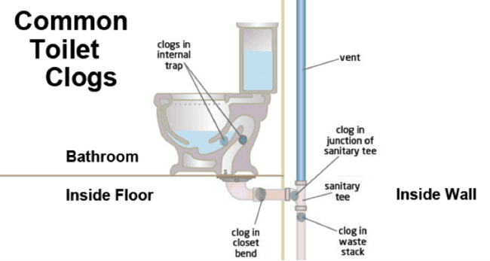

Figure 8: Common toilet clog points. King Arthur Plumbing. “Common Toilet Clogs.” King Arthur Plumbing, 2023, kingarthurplumbing.com/blog/common-causes-behind-toilet-clogs/.

### Cabinet

* Door damaged or fallen off
  1. Identify the type of hinge - common types are butterfly, concealed, or European style. This determines how to adjust them.
  2. Check if hinge screws are loose and tighten with a screwdriver if so. Don't overtighten, or wood holes could be stripped.
  3. Clean hinge joints with a damp cloth to remove any debris or grease buildup.
  4. Apply a lubricant like WD-40 or silicone spray to the hinge joint if squeaky.
  5. Adjust cabinet door alignment by loosening hinge screws slightly and repositioning door.
  6. Shim hinges with thin washers if the door is sagging or unaligned with the cabinet face.
  7. Replace damaged or worn out hinges. Use same size and style hinge for replacement.
  8. Update old hinges to soft-close dampers to prevent slamming and damage.
  9. Ensure doors are hanging flat by adjusting lateral hinge screws if present.
  10. Align hinge plates so door closes cleanly against cabinet frame without gaps.
  11. Video content: <https://www.youtube.com/watch?v=DI_9rozp_Mc>
* Countertop damaged
  1. Thoroughly clean and dry the damaged area. Sand down any rough edges.
  2. For chips, fill with a coloring-matched enamel touch-up kit or epoxy filler and smooth when dry.
  3. For cracks, use caulk sealant designed for countertops. Clean seam first and apply neatly.
  4. For laminate, use contact cement to re-adhere any lifted sections or seams. Clamp until bonded.
  5. For solid surface, sand out scratches and use rubbing compound to blend shine. Re-seal with resin.
  6. For cultured marble, repair tub-style chips with coloring-matched acrylic patch. Fill seam with clear caulk.
  7. For granite, wood, or other materials, consult a countertop pro for best repair method. May require cutting out and replacing sections.
  8. Use sharp razor to scrape off old caulk or glue residue. Re-caulk around sinks/faucets.
  9. Take safety precautions - wear gloves, mask, eye protection when making repairs.
  10. For extensive damage, replacing the entire countertop may be better option than continued repairs.
  11. Video content: <https://www.youtube.com/watch?v=vnkJlOQLXUo>

### Sink & Associated Plumbing

* Leaking into cabinet below
  1. Try plunging the drain first to clear any clogs. Cover overflow holes fully when plunging.
  2. Use a zip-it style drain cleaner to pull hair and debris from drain pipe.
  3. Check pipes under sink for leaks and tighten any loose slip joints or connections.
  4. Take apart the P-trap and clean out any built up gunk or clogs.
  5. Dump baking soda and vinegar down the drain, let sit 30 mins, then rinse with hot water.
  6. Use a drain snake or auger if drain is still backed up. Take care not to scratch porcelain.
  7. Remove pop-up sink stopper and clean built-up debris from mechanisms.
  8. If necessary, remove entire P-trap assembly and replace corroded or damaged parts.
  9. Check sink strainer/basket for debris blocking water flow and remove if needed.
  10. Hire a plumber if significant blockages persist or pipes under sink need replacement.
  11. Video content: <https://www.youtube.com/watch?v=T_QJf3TKvLM>
* Drain will not shut
  1. Remove drain stopper assembly and inspect rubber gasket for wear or damage. Replace if deteriorated.
  2. Clean stopper seat and ensure no debris is obstructing a tight seal. Scrub with brush or pipe cleaner.
  3. Check drain flange screws are tightened fully. Tighten or replace stripped screws.
  4. Take apart pivot rod assembly and clean internal parts of any built-up gunk or mineral deposits.
  5. Make sure pivot rod can move freely without friction. Lubricate joints with silicone spray if sticky.
  6. Look for cracks or stripped threads on clevis, tailpiece, or pop-up plug rod. Replace parts as needed.
  7. Reassemble drain mechanism ensuring spring and retaining nut are reinstalled correctly.
  8. Verify pop-up assembly alignment allows unobstructed vertical motion. Adjust as needed.
  9. If still not sealing properly, remove stopper and wrap plumber's tape around flange threads for tighter fit.
  10. Consider replacing entire drain plug assembly if worn parts cannot be repaired.
  11. Video content: <https://www.youtube.com/watch?v=oe0VKRMl4K0>
* Faucet leaking or not working
  1. Check under sink for any leaking pipes or loose connections and tighten as needed.
  2. Turn off hot and cold water supply lines to faucet and turn faucet on to relieve pressure.
  3. Disassemble faucet handle and cap to access cartridge or valve. Check for debris.
  4. Remove cartridge/valve and inspect washers, O-rings, seals for damage. Replace as needed.
  5. Scrub interior faucet parts with vinegar and water to remove mineral buildup.
  6. Replace cartridge/valve and reinstall handle components. Be sure parts are aligned.
  7. Turn on water supply and check for leaks. Tighten connections if leaking persists.
  8. Take faucet apart and reposition any incorrectly seated washers, seals or cartridge.
  9. Remove faucet aerators and filters and clean out any accumulated sediment.
  10. Replace faucet if repair parts no longer available or issues persist.
  11. Video content: <https://www.youtube.com/watch?v=rcV6CwoKwGg>

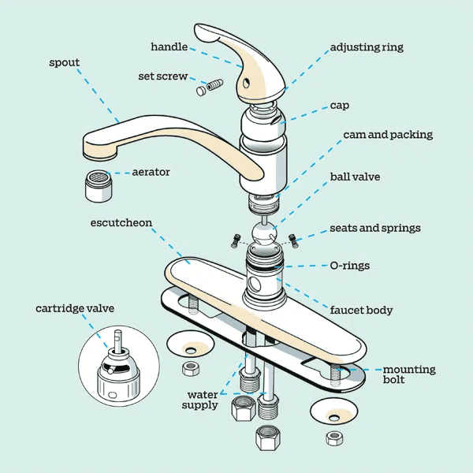

Figure 9: Parts of a sink faucet. Fann-Im, Nancy. “Kitchen Faucet Parts: Everything You Need to Know.” This Old House, 2023, www.thisoldhouse.com/kitchens/21097151/the-anatomy-of-a-kitchen-faucet.

* Plumbing under the sink is leaking
  1. Try plunging the drain first to clear any clogs. Cover overflow holes fully when plunging.
  2. Use a zip-it style drain cleaner to pull hair and debris from drain pipe.
  3. Check pipes under sink for leaks and tighten any loose slip joints or connections.
  4. Take apart the P-trap and clean out any built-up gunk or clogs.
  5. Dump baking soda and vinegar down the drain, let sit 30 mins, then rinse with hot water.
  6. Use a drain snake or auger if drain is still backed up. Take care not to scratch porcelain.
  7. Remove pop-up sink stopper and clean built-up debris from mechanisms.
  8. If necessary, remove entire P-trap assembly and replace corroded or damaged parts.
  9. Check sink strainer/basket for debris blocking water flow and remove if needed.
  10. Hire a plumber if significant blockages persist or pipes under sink need replacement.
  11. Video content: <https://www.youtube.com/watch?v=T_QJf3TKvLM>

### Medicine Cabinet or Mirror

* Door fell off hinges
  1. Identify the type of hinge - common types are butterfly, concealed, or European style. This determines how to adjust them.
  2. Check if hinge screws are loose and tighten with a screwdriver if so. Don't overtighten, or wood holes could be stripped.
  3. Clean hinge joints with a damp cloth to remove any debris or grease buildup.
  4. Apply a lubricant like WD-40 or silicone spray to the hinge joint if squeaky.
  5. Adjust cabinet door alignment by loosening hinge screws slightly and repositioning door.
  6. Shim hinges with thin washers if the door is sagging or unaligned with the cabinet face.
  7. Replace damaged or worn out hinges. Use same size and style hinge for replacement.
  8. Update old hinges to soft-close dampers to prevent slamming and damage.
  9. Ensure doors are hanging flat by adjusting lateral hinge screws if present.
  10. Align hinge plates so door closes cleanly against cabinet frame without gaps.
  11. Video content: <https://www.youtube.com/watch?v=DI_9rozp_Mc>
* Mirror broken
  1. Tape length-wise over crack temporarily while waiting for new mirror.
  2. Carefully remove the broken mirror fragments and dispose properly. Wear gloves for protection.
  3. Remove old mirror mounting hardware - screws, brackets, adhesives from wall. Patch and repaint wall if needed.
  4. Measure area where mirror will hang and purchase a new mirror of the same or slightly smaller size.
  5. Choose mounting method - clips, liquid nails, screws into studs. Ensure it's secure for a heavy mirror.
  6. Drill pilot holes in new mirror if using screws. Position horizontally for an even look.
  7. Clean mirror back and wall area with alcohol. Apply adhesive tabs, mirror tape, or construction adhesive.
  8. Mount new mirror on wall, ensuring it is centered and level by taking measurements.
  9. If using mounting clips or hardware, attach to wall first then hang mirror. Adjust as needed.
  10. Use decorative molding, clips or holders around edges to finish off look.
  11. Apply sealant around perimeter if gap between wall and mirror frame to prevent moisture damage.
  12. Video content: <https://www.youtube.com/watch?v=ZFY37sop9OY>

### Bathtub & Associated Plumbing

* Water leaks damaging flooring
  1. Inspect flooring for discoloration, swelling, mold, or rot to pinpoint affected areas. Probe with awl to check for sponginess.
  2. Remove any wet carpeting, underlayment, and floorboards to access subfloor. Dry out subfloor thoroughly.
  3. Check if subfloor is salvageable or needs replacement. Solid, unaffected areas can be kept.
  4. Use a moisture meter to test wood moisture content before installing new flooring. Wait until it matches surroundings.
  5. Cut away any rotted or moldy sections of subfloor and replace with matching plywood.
  6. Install new, matching floor joists or structural supports if needed.
  7. Replace insulation under the floor if it got soaked. Use mold resistant materials.
  8. Clean, sand, and primer subfloor prior to new flooring installation.
  9. Match flooring thickness of replacement boards or underlayment to existing.
  10. Refasten new floor following manufacturer’s directions. Nail/glue perimeter first then work inward.
  11. Video content: <https://www.youtube.com/watch?v=xqguFDE1wOo>
* Faucet wont’ shut off
  1. Check for debris or mineral buildup in faucet aerator and clean or replace aerator.
  2. Remove faucet handle and inspect interior components for wear, damage, or misalignment. Repair or replace parts like cartridge, cam, seals.
  3. If a compression faucet, check faucet seat and washer condition. Replace if worn out.
  4. Verify shut off valves under sink are fully closed. Replace leaky valves.
  5. Disassemble valves and clean any grit or buildup from working parts. Lubricate parts like stems and O-rings.
  6. Check water supply lines for cracks, improper connectors, or valve problems allowing water to flow.
  7. Replace inlet hoses going to faucet supply tubes if they have bulges or cracks. Tighten fittings.
  8. Use pipe wrench to ensure bonnet nut holding faucet body to sink is fully tightened.
  9. Replace faucet cartridge, valve seats, stems if no specific part identified as causing leak.
  10. Replace entire faucet assembly if significant internal damage presents safety issue.
  11. Video content: <https://www.youtube.com/watch?v=zMH61Yabdj0>
* Not enough flow from shower
  1. Check for clogged shower head openings and clean out any debris or mineral buildup.
  2. Remove shower head flow restrictor and clean it if partially blocked.
  3. Check shutoff valves and ensure they are fully open. Open hot and cold valves completely.
  4. Inspect the shower arm and make sure no debris is clogging the arm. Remove and clean threads.
  5. Check main home water pressure at other faucets. If pressure is low throughout, inspect main lines.
  6. Remove tub spout diverter and clean out any debris inside blocking flow to shower head.
  7. Replace old or kinked shower hoses that can reduce water volume.
  8. Make sure shower head matches your water systems pressure rating - install pressure balancer if needed.
  9. Clean out aerators and filters on tub faucet to improve pressure to the shower head.
  10. Replace the shower head with a quality, higher flow rated model if other issues not found.
  11. Video content: <https://www.youtube.com/watch?v=qD_-QWTnZr4>
* Hot or Cold adjustment not working
  1. Check shower cartridge or valves for sediment buildup or corrosion preventing smooth adjustment. Descale and clean.
  2. Test shower valves independently to isolate issue to hot or cold side. Replace faulty cartridge or valve.
  3. Make sure hot and cold supply lines are properly connected to the right inlets on shower valve.
  4. Shut off valves allowing each supply line to be isolated and checked separately for flow and temperature.
  5. Clear out debris and mineral deposits from shower head which can block flow and cause improper mixing.
  6. Replace old or worn out rubber washers and seals on shower valves that may be leaking and allowing crossflow.
  7. Adjust maximum temperature stop ring on shower valve if temperature exceeds safe limits.
  8. Install temperature regulating valves if issues persist to automatically prevent unsafe discharge temps.
  9. Replace faulty anti-scald valves meant to maintain stable outlet temperature.
  10. Hire a plumber to verify adequate hot water supply from water heater if cause unclear.
  11. Video content: <https://www.youtube.com/watch?v=lZN_pK0CCYo>

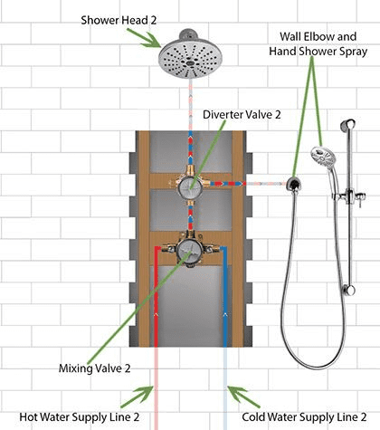

Figure 10: Basic diagram of shower mixing valve. “Complete Guide to Shower System with Body Jet Sprays and Hand Shower Installation.” FaucetList.Com, 2023, faucetlist.com/blogs/buying-guides/complete-guide-to-shower-system-with-body-jet-sprays-and-hand-shower-ins

* Shower will not come on
  1. Check shower valves are fully open. Test hot and cold valves independently to isolate issue.
  2. Inspect showerhead for blockages like mineral deposits or sand. Remove and clean showerhead.
  3. Verify water supply shutoff valves are fully open. Open both hot and cold supply lines.
  4. Check for faulty diverter valve. Should allow water flow to the showerhead when engaged. Replace if needed.
  5. Test shower faucet handles - if no flow, issue is in the valves. Repair/replace cartridges.
  6. Clear out debris in shower arm curve and shower riser. Disconnect and back flush with water.
  7. Remove tub spout diverter and clean out any debris blocking flow up to the shower head.
  8. Replace cracked or damaged supply tubes not allowing water to reach the shower valves.
  9. Unclog shower drain if slow drainage is preventing valve from closing fully. May indicate venting issue.
  10. Video content: <https://www.youtube.com/watch?v=qnLMwkbU1V0>

### Towel Rack

* Repair damaged towel rack
  1. Check if mounting hardware like screws or toggles are loose and not holding rack securely. Tighten or replace.
  2. Use plastic screw hole inserts to re-use old holes which have become stripped.
  3. For tension pole racks, make sure adjustable pole is turned to expand tight between floor and ceiling.
  4. Test weight capacity and do not overload rack if hardware is pulling out of wall.
  5. If mounting to tile, use appropriate anchors like toggle bolts to support weight. Plastic anchors can fail.
  6. Consider relocating rack to wall stud if original location does not provide robust backing.
  7. Check set screws or support arms of rack for stripping or damage. Replace brackets if needed.
  8. Take down rack. Fill old holes with spackle and sand smooth when dry. Repaint before remounting.
  9. For rusty towel racks, remove rust with naval jelly or steel wool. Repaint to inhibit future rust.
  10. Ensure rack is properly level and bars are spaced correctly when reinstalling.
  11. Purchase new rack that fits space appropriately rather than trying to remount unsturdy one.
  12. Video content: <https://www.youtube.com/watch?v=89885nbTesM>
* Install new towel rack
  1. Select proper location for towel rack, considering space for opening/closing doors and use.
  2. Measure desired height and spacing from wall for towel rack and mark with pencil.
  3. Use stud finder to locate studs. Mark stud centers for optimum support.
  4. If installing into drywall, use hollow drywall anchors appropriate for weight of rack and towels.
  5. For tile walls, mark mounting holes then use carbide drill bit to drill holes for screw anchors.
  6. For racks with a shelf, install bottom mounts first. Level and mark top mounts.
  7. Use drill appropriate for surface to pre-drill holes for anchors and screws.
  8. Insert plastic anchors (if used) gently with hammer until flush with wall.
  9. Align towel rack to marks and insert screws into pre-drilled holes or anchors.
  10. Do not over tighten small screws. Tighten until snug and towel rack is stable on wall.
  11. Video content: <https://www.youtube.com/watch?v=nh7xpJNJD5Y>

### Tissue Holder

* Repair damaged tissue holder
  1. Check if mounting hardware like screws or toggle bolts are loose. Tighten or replace hardware.
  2. Ensure holder parts like brackets, rods, and spindles are intact. Order replacement parts if broken.
  3. Take holder down and ensure mounting surface is solid. Toggle bolts work better than plastic anchors.
  4. Consider relocating holder closer to toilet if current position makes access difficult.
  5. Clean adhesive residue or paint from previous holder off mounting area for better adhesion.
  6. For loose spindles, remove holder and apply thread adhesive or sealant before reinstalling.
  7. Check spring tension on adjustable holder models. Replace spring if needed to improve tension.
  8. If holder is damaged beyond repair, purchase new holder designed for bathroom use.
  9. When reinstalling, make sure holder is level, spaced correctly from wall, and rolls spin freely.
  10. Apply clear silicone sealant around new holder base to prevent moisture damage.
  11. Video content: <https://www.youtube.com/watch?v=Ws_2DbDMIX0>

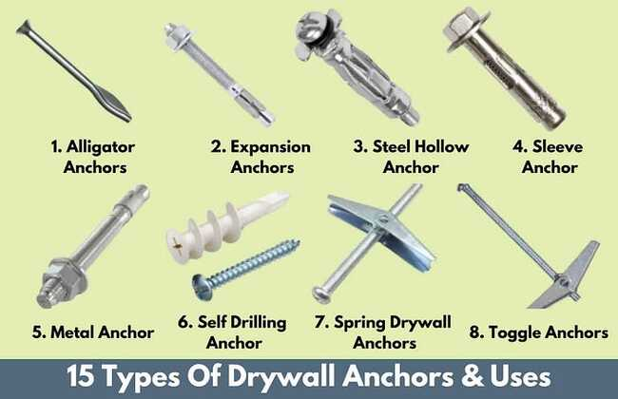

Figure 11: Types of drywall anchors. Mahajan, Mike. “15 Types of Drywall Anchors | Different Types Of Wall Anchors | Dry Wall Anchors Types | Best Types of Wall Anchors For Wall.” Medium, 6 Oct. 2022, civiconcepts.medium.com/15-types-of-drywall-anchors-different-types-of-wall-anchors-dry-wall-anchors-types-best-types-2773dc4741b0.

### Exhaust Fan

* Will not turn on
  1. Check if fan is getting power - turn off power first, then inspect wiring connections.
  2. Remove cover and check if fan blades spin freely. Look for obstructions like dirt or insect nests.
  3. Clean fan blades, motor housing, and vents with small brush or vacuum to remove dust buildup.
  4. Test capacitors and motors for signs of failure like humming. Replace defective part.
  5. Check ducting for leaks, gaps, or clogs. Repair and realign as needed to optimize airflow.
  6. Remove fan motor and lubricate shaft bearings if noisy. Use electrical contact cleaner on switch terminals.
  7. Make sure ducting is vented to exterior. Recirculation kits can allow moisture buildup.
  8. Replace cracked or damaged fan housing. Unstable housing can misalign moving parts.
  9. Install new mounting hardware matched to fan weight if current hardware is insufficient.
  10. Call an electrician if issue persists after cleaning and component replacement. May require new wiring.
  11. Video content: <https://www.youtube.com/watch?v=vgW3d1yksTU>
* Extremely noisy
  1. Turn off the power to the fan at the circuit breaker before inspecting or doing any work.
  2. Remove the fan cover and inspect the fan blades for dust buildup. Clean the blades if needed. Dust can cause imbalance and noise.
  3. Check that the fan blades spin freely by spinning them with your hand. Stiff or grinding blades can cause noise.
  4. Listen closely to the type of noise the fan is making. Grinding, rattling, squeaking noises point to different issues.
  5. Check that the fan is secure in the housing and not rattling around. Tighten screws if needed.
  6. Inspect the fan motor for wear and overheating issues if noise is mechanical. Replace motor if worn out.
  7. Check that fan blade is balanced and aligned. Bent blades can cause wobble and noise. Carefully bend back into shape if needed.
  8. Lubricate fan motor and brackets with a small amount of machine oil like 3-in-1 oil. Squeaks may indicate lack of lubrication.
  9. Video content: <https://www.youtube.com/watch?v=pKTzSB2vcrg>

## Bedrooms

* See other common Items
* Closet rack falling down or damaged
  1. Broken shelf bracket - Remove shelf, detach bracket, install replacement bracket at same height, reattach shelf.
  2. Shelf detached from sheetrock – repair the sheetrock first, then re-install the rack with more sturdy screws.
  3. Shelf cracked from heavy item - Remove shelf, sand edges, cut replacement wood to size, stain/paint to match, install replacement shelf, avoid overweighting shelves.
  4. Video content: <https://www.youtube.com/watch?v=8Mw_xXynMSI>

## Arctic Entry

* Common Items

### Front Door

* Doorknob or deadbolt issues
  1. Check that the door is properly aligned in the frame and not sagging. Realign door if needed.
  2. Make sure the latch plate is screwed in properly. Tighten screws if needed.
  3. Ensure the spindle and latch bolt can move freely and are lubricated. Use powdered graphite or spray lubricant.
  4. Remove knob and inspect interior components for wear, damage or loose parts. Replace any worn springs or pins.
  5. Verify the latch bolt is retracting fully when rotating knob. File edge if scraping against strike plate.
  6. Lightly sand any rough areas on the knob spindle or latch area. Lubricate with graphite powder or spray lubricant.
  7. Check that knob and deadbolt latch alignment is correct. Adjust screws if out of alignment.
  8. Inspect the strike plate on the door frame and make sure screws are tight. Tighten or replace if loose.
  9. Remove the door knob and inspect the interior mechanisms. Look for worn or broken parts and replace.
  10. Make sure screws holding knob assembly together are tight. Tighten with screwdriver if loose.
  11. For sticky or hard to turn knobs, remove knob and clean interior parts with soap and water. Fully dry and re-lubricate before replacing.
  12. Video content: <https://www.youtube.com/watch?v=L5oA0-EGpCA>
* Hinge troubleshooting
  1. Inspect the hinge pins and make sure they are properly seated in the knuckle joints. Reseat any loose pins.
  2. Tighten any loose screws in the hinge plates. Use a screwdriver to tighten them snugly into the door frame and door.
  3. Lightly sand any rough or stuck areas on the hinge pins. Apply lubricant like WD-40 or silicone spray to the pins.
  4. Check alignment of the hinge plates. Shim any gaps or misalignments with thin cardboard or felt pads.
  5. Test to see if the pins turn freely in the knuckle by removing the pins and reinserting. Replace if worn.
  6. For squeaks, apply a small amount of silicone lubricant between the knuckle joints. Allow to dry before reattaching door.
  7. Consider replacing old or worn out hinges with new ones of the same size and type.
  8. If the door still sags, add additional shims above the top hinge to raise the door until properly aligned.
  9. Video content: <https://www.youtube.com/watch?v=w0Po_lhuLck>
* Weather stripping
  1. Inspect the door seals and strips around the frame, threshold, and stop molding. Look for gaps, cracks, or missing sections.
  2. Use the "light test" to check for leaks - close the door and check for light coming through at the seals. Mark any leaks.
  3. Check if seals are just dirty or stained. Clean dirty seals with water and mild detergent using a soft brush.
  4. Tighten any loose screws or nails on metal weatherstripping. Adjust self-adhesive seals by removing and reapplying.
  5. Replace any excessively worn, cracked, or missing seals with new weatherstripping of the same type and size.
  6. Make sure weatherstripping is aligned properly so it makes uniform contact. Trim any overhanging material.
  7. Apply lubricant like wax stick or silicone spray to the seals to rejuvenate and improve contact.
  8. Adjust door sill threshold height if scrape marks indicate it's too tight. Some gap is ideal to allow seal compression.
  9. Video content: <https://www.youtube.com/watch?v=JUx0cjbzbhs>
* Door cannot close completely
  1. Check if door stops or rubs against jamb or frame before closing fully. Sand or plane any spots on door if needed.
  2. Inspect hinges to make sure they are aligned and properly seated. Tighten any loose hinge screws.
  3. Adjust strike plate slightly if alignment with door latch is off. Loosen plate screws and reposition.
  4. Make sure door latch bolt is extending fully when handle is turned. Adjust or replace latch if needed.
  5. Check for any obstructions near floor such as flooring material or carpet. Trim if necessary.
  6. Determine if settling has caused door frame to become out of square. Shim hinge side to raise door if needed.
  7. Make sure door side jambs are plumb. Realign if shifted. May need to reposition stops.
  8. Look for loose weatherstripping or door seals that may be sagging and blocking closure. Reattach or replace seals.
  9. Video content: <https://www.youtube.com/watch?v=SAgDwFDqxVM>
* Drafty weatherstripping
  1. Inspect the door seals and strips around the jamb and threshold. Look for gaps, cracks, or missing sections that can cause air leaks.
  2. Check if existing weatherstripping is loose and needs to be firmly reattached with screws or adhesive. Replace any that are damaged.
  3. Make sure the weatherstripping meets tightly against the door when closed. If not, adjust door alignment or trim weatherstripping.
  4. Clean dirty seals by wiping down with water and mild detergent. Dust buildup can prevent proper sealing.
  5. Ensure the door's edges and seal contact surfaces are smooth. Lightly sand any rough areas if needed.
  6. Apply lubricant like silicone spray to the rubber or vinyl seals to rejuvenate. Avoid petroleum-based products.
  7. Consider replacing worn weatherstripping with new, higher quality materials if re-attachment and cleaning doesn't work.
  8. For the threshold, check for warping or gaps and fill with seals specifically made for thresholds.
  9. Video content: <https://www.youtube.com/watch?v=JjmTlWE-6h8>

### Second Door

* See Front door above

## Mechanical Room

* Common Items

### Door & Hardware

* See Front door above

### Boiler

* Smell of fuel
  1. Check the fuel tank and lines for any leaks that could be releasing fuel odor. Seal any leaks found.
  2. Inspect the fuel pump and make sure it is not overfilling the burn pot and spilling fuel. Adjust flow rate if needed.
  3. Clean the fuel filter and replace if clogged. Clogs can cause excess fuel flow past the burner.
  4. Check the fuel atomizer and burner assembly for proper alignment. Adjust or replace worn parts as needed.
  5. Inspect the flue venting and make sure there are no blockages. Ventilation issues can trap odors.
  6. Consider upgrading to an electronic oil solenoid valve if older model relies on oil pressure. More precise control.
  7. Check oil burner nozzle size and pattern. Improper size or spray can lead to incomplete combustion and smell.
  8. Have a service technician do a combustion test to optimize burner performance and air-fuel ratio.
  9. Video content: <https://www.youtube.com/watch?v=2lH2VaXz9KI>

Figure 12: Common parts of a household oil fueled boiler. “Oil-Fired Boilers.” Building America Solution Center, 31 July 2017, basc.pnnl.gov/resource-guides/oil-fired-boilers.

* Smell of exhaust
  1. Check the flue venting and exhaust pipe for any blockages or leaks that could allow exhaust gas back into the building.
  2. Inspect the burner assembly and heat exchanger for cracks or damage that may be leaking exhaust.
  3. Make sure the draft inducer fan is operating properly to vent fumes. Replace if worn out or spinning slowly.
  4. Clean the burner nozzle assembly if sooty buildup is present. Soot can restrict exhaust flow.
  5. Verify there is adequate make-up combustion air getting to the boiler room. Open vents if restricted.
  6. Have a technician adjust the air-fuel mixture by checking the fuel pressure and nozzle size. Too rich causes incomplete combustion.
  7. Test the boiler exhaust with a combustion analyzer to check for high CO levels. Tune the burner if needed.
  8. Consider upgrading old boiler smoker exhaust piping to sealed pipe design to prevent exhaust leaks.
  9. Video content: <https://www.youtube.com/watch?v=cSOyQ67nFvI>
* Runs all the time
  1. Check that the thermostat is set properly and functioning. Lower to temperature below room temp to trigger shutdown.
  2. Inspect the burner electrodes for dirt buildup or cracks, preventing flame detection. Clean or replace.
  3. Check for faulty wiring connections to the control thermostat and operating valves. Tighten or repair wiring.
  4. Remove and check the cad cell/photocell that detects flame. Clean sooty cell or replace.
  5. Verify fuel pump pressure and regulator settings are correct. Adjust to proper specs if too high.
  6. Check oil nozzle size and pattern. Wrong spray can lead to flame rollout and constant burning.
  7. Remove any corrosion and mineral buildup in lines and valves causing sticking. Descale and clean.
  8. Do a combustion test and efficiency check.
  9. Video content: <https://www.youtube.com/watch?v=0_M4aeF1X4E>

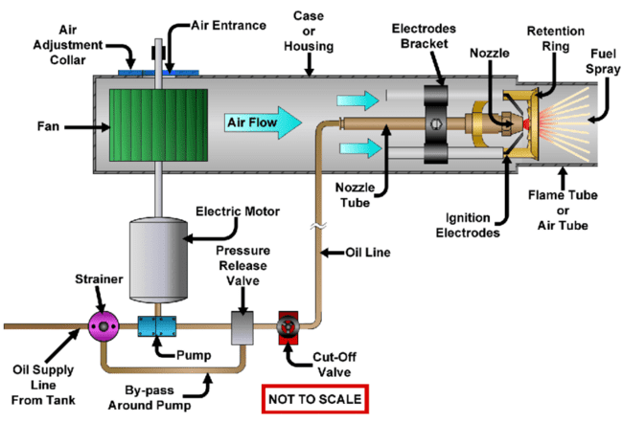

Figure 13: Schematic of a typical oil burner within an oil fueled boiler. Tutu, et al. “On the Role of Electrodes in Introducing Airflow Distortion in Residential Oil Burners.” Research Gate, Jan. 2019, www.researchgate.net/figure/Schematic-of-a-typical-oil-burn

* Will not turn on
  1. Check the thermostat and make sure it is set properly and calling for heat. Adjust temperature setting if needed.
  2. Inspect the burner motor and ignition electrodes. Clean or replace if excessively dirty.
  3. Verify the fuel tank has sufficient oil and all fuel valves are open. Replenish tank and open valves as needed.
  4. Check for blown fuses or tripped circuit breakers related to boiler system. Reset breakers and replace any blown fuses.
  5. Inspect oil filter and lines for clogs preventing fuel flow. Replace filter and clear any obstructions.
  6. Check cad cell/photocell for soot blockage not allowing burner ignition. Clean cell gently or replace.
  7. Remove air from fuel pump and lines. Purge air by loosening fittings to bleed air when pump is on.
  8. Test oil burner motor, ignition, and operating controls with multimeter for faults. Replace faulty components.
  9. Video content: <https://www.youtube.com/watch?v=cog7MaShR7M>
* Burning lots of fuel
  1. Check for leaks in the fuel supply lines or tank that may be allowing oil to escape. Seal any leaks found.
  2. Inspect the oil burner nozzle for proper size and spray pattern. Replace nozzle if worn or oversized.
  3. Verify the fuel pump pressure setting and adjust if higher than nozzle manufacturer specification.
  4. Clean the fuel filter and replace if excessively dirty. Clogged filters increase oil consumption.
  5. Inspect combustion chamber and flue for soot buildup which can lower boiler efficiency over time. Clean thoroughly.
  6. Check the cad cell/photocell sensor that controls the burner. Replace if intermittently firing burner.
  7. Have a technician perform a combustion analysis to optimize air-fuel ratio. Improvements can reduce fuel use.
  8. Consider adding an outdoor temperature sensor reset control to modulate firing rate based on heating demand.
  9. Video content: <https://www.youtube.com/watch?v=glpZMRmGfRc>
* Making loud noises
  1. Check for rumbling or grinding noises that may indicate a problem with the burner motor or fuel pump. Replace defective parts.
  2. Listen for hissing, whistling, or roaring sounds that could mean combustion air or flue gas flow issues. Inspect venting.
  3. Bangs or pops may signal delayed ignition caused by faulty electrodes or improper fuel atomization. Check electrodes and nozzle.
  4. Knocking or hammering noises indicate heat exchanger or furnace issues.
  5. Inspect boiler base and mountings for looseness. Tighten fasteners if boiler is rattling against floor or walls.
  6. Check for vibrating pipes that may need support braces or pipe clamps to reduce rattles from water circulation.
  7. Make sure fuel tank is not empty causing sputtering from lack of steady oil supply while burner runs. Refill tank.
  8. Listen and isolate source of hissing or squealing indications potential steam or water leaks. Repair any found leaks.
  9. Video content: <https://www.youtube.com/watch?v=mspZYb-J8Qc>

### Hot Water Maker

* No hot water
  1. Check that the thermostat is set to call for heat and is functioning properly. Adjust temperature setting as needed.
  2. Inspect the pilot light assembly and relight if needed. Make sure flame is blue and steady.
  3. Check water pressure gauge and refill to correct psi if low. Low pressure will prevent water from circulating.
  4. Make sure all zone valves are open and operating properly. Open manually if needed.
  5. Bleed radiators and baseboards to release trapped air preventing circulation.
  6. Inspect the circulator pump and make sure it is running when heat is called for. Restart or replace if faulty.
  7. Check supply and return pipes for closed valves or clogs from sediment. Open all valves and flush pipes if needed.
  8. Inspect boiler heating elements and thermostats. Test with multimeter and replace controls if defective.
  9. Video content: <https://www.youtube.com/watch?v=wSrk1zB4EWk>
* Water too hot
  1. Check that the thermostat is set properly and functioning accurately. Lower temperature setting if too high.
  2. Inspect the mixing valve and make sure it is adjusted to temper water to desired temperature. Adjust if necessary.
  3. Test the thermocouple or thermostat sensor with a multimeter. Replace control if giving incorrect high readings.
  4. Make sure the high limit safety controls are operating properly and shutting off at maximum safe temps.
  5. Check flow valves and circulating pump operation. Sediment or clogs can restrict water flow and overheat.
  6. Bleed all radiators and baseboards to remove trapped air that can cause overheating.
  7. Clean heat exchanger surfaces if heavy scale buildup is reducing heat transfer and efficiency.
  8. Inspect heating elements and wiring. Defective components could be delivering excess heat. Test and replace.
  9. Video content: <https://www.youtube.com/watch?v=Ch3ky5aM_mM>

Figure 14: Common gas fueled water heater components. Marisa. “Basics of Gas Appliances.” Advanced Home Energy, 19 Mar. 2014, advancedhomeenergy.com/blog/.

* Water too cold
  1. Check the thermostat and make sure it is set to the desired temperature. Adjust setting upwards as needed.
  2. Inspect the pilot light assembly and relight if needed. Make sure flame is steady.
  3. Test heating elements with a multimeter for continuity. Replace any defective heating elements.
  4. Check water pressure gauge. Refill with water to correct psi if pressure is low.
  5. Inspect circulation pump operation and restart if not pumping adequately. Replace worn pump if needed.
  6. Make sure all zone valves are open and operating properly. Open fully if any are partially closed.
  7. Bleed radiators and baseboards to remove trapped air reducing circulation.
  8. Clean heat exchanger surfaces if heavy scale buildup is preventing heat transfer. Descale as needed.
  9. Video content: <https://www.youtube.com/watch?v=o-LsUWlWVh0>

### Zone Valves & Thermostats

* Water temperature issues (see under Hot Water Maker)
* Heat not turning on in certain areas of home
  1. Check the thermostat and make sure the temperature is set higher than the room's temperature and it's calling for heat.
  2. Check thermostats in the zone and replace batteries or any defective thermostats.
  3. Inspect the zone valves for the unheated rooms and make sure they are open. Open manually if closed.
  4. Bleed radiators and baseboards in the cold areas to remove trapped air preventing circulation.
  5. Check the radiator valves and make sure they are open fully to allow hot water flow.
  6. Inspect the circulating pump and filters for blockages. Clean and clear any found debris.
  7. Look for closed supply/return valves for the zone. Make sure all valves are open.
  8. Test the zone control board and replace if faulty. This controls power to the zone's pump and valves.
  9. Video content: <https://www.youtube.com/watch?v=qKZqsO8yx4M>
* Certain areas of home too hot
  1. Check the thermostat in the hot area and lower the temperature setting if it's too high.
  2. Check for items around the room or doors which could be preventing proper ventilation.
  3. Inspect radiator valves and partially close in rooms that are too warm to restrict hot water flow.
  4. Make sure zone valves for the area are properly adjusted and not stuck open. Adjust or replace if needed.
  5. Check for radiator air vents that may be closed, preventing bleed off of excess heat. Open vents.
  6. Feel supply and return pipes for the zone. If one is hot and the other cool, circulation is restricted.
  7. Clean circulating pump impeller and housing if covered in debris causing flow restriction.
  8. Consider upgrading room thermostats to newer digital models for more precise temperature control.
  9. Insulate supply pipes and radiators in affected rooms to reduce heat radiation intensity.
  10. Video content: <https://www.youtube.com/watch?v=qOGnUWi43kg>
* Certain areas of home too cold
  1. Check for items around the room or doors which could be preventing proper ventilation.
  2. Check for open windows, door and windows with drafts. Repair, replace or upgrade windows and doors with bad seals.
  3. Check the thermostat in the cold rooms and turn up the temperature setting if too low.
  4. Inspect radiator valves and make sure they are fully open to allow hot water flow. Open further if needed.
  5. Bleed radiators in cold areas to remove trapped air preventing heat circulation.
  6. Verify zone valves for the cold area are open fully. Adjust or replace valve if not functioning properly.
  7. Check for closed supply/return valves for the zone. Open fully if found closed.
  8. Insulate exposed pipes and radiators in cold rooms to prevent heat loss.
  9. Look for leaks in pipes or radiators within the zone that may be losing heat. Repair any found leaks.
  10. Consider upgrading room thermostats to newer digital models for more accuracy.
  11. Consider upgrading windows and doors which don’t provide adequate seals and insulation.
  12. Consider installing additional insulation around the house.
  13. Video content: <https://www.youtube.com/watch?v=us1IQx65bQI>

### Expansion Tank

* Pressure relief valve tripping
  1. Check the expansion tank pressure and compare to system pressure. Refill tank air to match if needed.
  2. Inspect tank bladder or diaphragm for damage. Replace tank if bladder is defective and allowing water through.
  3. Make sure the tank is sized adequately for the system volume and temperature. Upgrade if undersized.
  4. Check for incorrectly closed valves preventing water from returning to tank when heated. Open all returns.
  5. Monitor system pressure for signs of over-pressurization from faulty fill valves or pumps. Repair cause.
  6. Inspect relief valve for mineral deposits or defects not allowing it to re-seat properly. Fully open and flush valve.
  7. Make sure there is no isolation valve restricting flow to relief valve inlet. Remove any valves found.
  8. Test valve discharge capacity and lift pressure. Replace if not operating to stated specs.
  9. Video content: <https://www.youtube.com/shorts/pGCPExUvxLs>

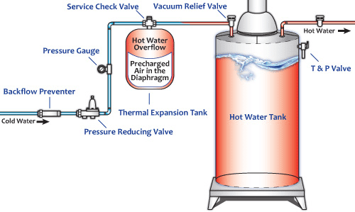

Figure 15: Water heater thermal expansion tank design. “Thermal Expansion Tanks.” Water Heat Rescue, 2023, Thermal Expansion Tanks.

* How to test
  1. Locate the rating information on the valve to identify the pressure setting and discharge capacity.
  2. Shut off and drain the isolation valves to remove pressure from the valve inlet.
  3. Lift and release the test lever at the valve inlet to flush any debris and ensure free movement.
  4. Attach a pressure gauge to the valve inlet port or piping to monitor test pressure.
  5. Use a pump to slowly pressurize the valve inlet, watching the gauge for the relief point.
  6. Continue pressurizing until the valve fully discharges at its listed capacity.
  7. Release pressure and allow the valve to reset. Repeat pressurization to test reseating.
  8. Compare test results to valve ratings for proper lift and discharge. Adjust if out of specification.
  9. Video content: <https://www.youtube.com/watch?v=S3PtYJed61c>

### Glycol Systems

* Glycol pressure too high
  1. Check the expansion tank pressure and pre-charge level. Refill tank air to proper psi if low.
  2. Inspect relief valves and make sure they are operating properly at their pressure rating.
  3. Monitor fill valve operation and repair if stuck open and overfilling system.
  4. Check glycol concentration with refractometer. Dilute and adjust to proper level if too high.
  5. Inspect system piping and components for any restrictions or closed valves preventing flow.
  6. Bleed air from the system manually at high points. Trapped air causes pressure buildup.
  7. Verify circulating pump operation. Check for proper flow direction, speed, and no air binding.
  8. Clean strainers if excessive debris is causing reduced flow and overheating. Flush system if needed.
  9. Video content: <https://www.youtube.com/watch?v=gOZWyZMOASA>

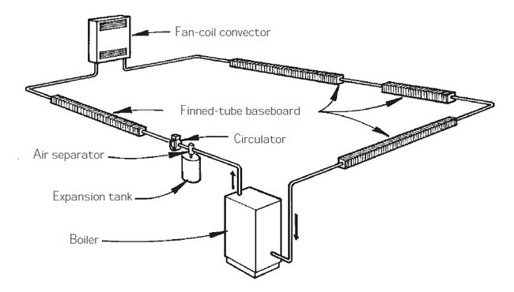

Figure 16: Diagram of a basic hyrdonic heating system. Siegenthaler, John. “Piping Layouts for Hydronic Heat.” The Journal of Light Construction, 2023, www.jlconline.com/how-to/hvac/piping-layouts-for-hydronic-heat_o.

* Baseboards are noisy (air in the system)
  1. Check glycol concentration with a refractometer. Low glycol levels can cause cavitation and noise. Top up if needed.
  2. Inspect the circulator pump and filters. Remove any debris that may be causing restriction and noise.
  3. Make sure automatic air vents at the baseboards are operating properly to bleed trapped air.
  4. Feel for vibrations along the supply and return pipes. Support or isolate vibrating pipes as needed.
  5. Check baseboard piping is properly pitched to avoid air pockets. Pitch 1/4 inch per foot of pipe run.
  6. Flush the hydronic system to remove sediment that could be causing noise at the baseboards.
  7. Listen for hissing sounds indicating steam in the system. Repair leaks and purge air to quiet steam noise.
  8. Video content: <https://www.youtube.com/watch?v=oyq4gTWVRhA>

### Circulation Pump

* When to turn on
  1. Program the pump to turn on during typical high use morning hours when most showers and sink use occurs. For example, 6-9 AM.
  2. Manually turn the pump on about 10-15 minutes before taking a shower or running hot water to prime the plumbing with hot water faster.
  3. Use a timer switch or smart controls to automatically turn the circulation pump on only during set morning and evening time periods.
  4. Activate the pump's built-in temperature sensor to turn on when the hot water tank drops below a preset temperature, indicating hot water is being used.
  5. Video content: <https://www.youtube.com/watch?v=AQC_shrv8KA>

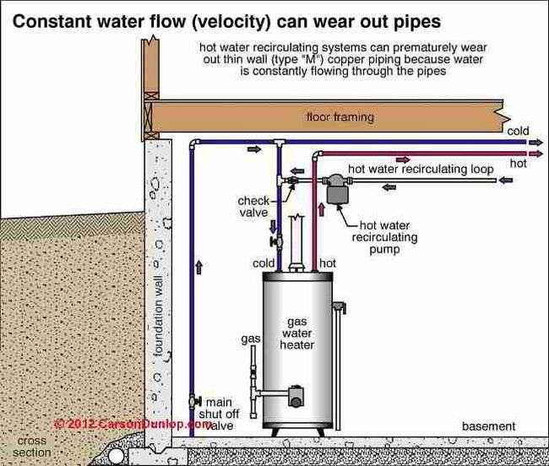

Figure 17: The pump keeps hot water circulating in a loop, removing the need to wait for the hot water heater at the tap. “Hot Water Recirculating Pump Diagram.” Inspectapedia.Com, 2023, inspectapedia.com/plumbing/1508s.jpg.

* How to check
  1. Turn on the pump and check that it is running - listen for operation and feel for vibration.
  2. Open hot water faucets at the furthest fixture and measure time for hot water arrival. Should be significantly faster than without the pump.
  3. Check that the pump turns off a short time after closing faucets. Continuous running indicates a problem.
  4. Test any pump activation controls like temperature sensors, timers, or motion sensors. Make sure pump responds properly.
  5. Monitor the pump's outlet temperature. Should be at least 110°F if supplying adequate hot water circulation.
  6. Measure the pump's discharge water flow if able. Compare to manufacturer specs for design flow rate to ensure proper operation.
  7. Video content: <https://www.youtube.com/watch?v=yCZqfnlBYW8>

### Boiler Temperature & Pressure

* Boiler getting too hot
  1. Check the thermostat and make sure it is set properly, not too high. Lower it to an appropriate temperature.
  2. Inspect the high limit switch and make sure it is functioning properly to shut off the boiler if overheating occurs.
  3. Test the thermostat sensors with a multimeter. Replace any faulty sensors giving incorrect high temp readings.
  4. Check for restricted water flow due to closed valves, clogged pipes, or a stuck circulator pump. Open all valves and clear any obstructions.
  5. Bleed radiators and baseboards to remove trapped air that can impede water circulation and lead to overheating.
  6. Clean heat exchanger surfaces if scale buildup is present, reducing efficiency and heat transfer.
  7. Inspect burner nozzle size and flame for proper combustion. Adjust fuel/air mixture as needed to prevent overfiring.
  8. Video content: <https://www.youtube.com/watch?v=Ch3ky5aM_mM&t=8s>
* Boiler shutting off too soon
  1. Check the thermostat and make sure it is set to the proper temperature. Raise it if too low.
  2. Inspect the low water cut-off switch and make sure it is functioning properly and at the right level. Adjust if needed.
  3. Check for sediment buildup in the heat exchanger that could trigger the high limit switch to trip prematurely. Descale if necessary.
  4. Test the thermostat sensors with a multimeter for calibration. Replace any inaccurate sensors.
  5. Refill to proper water level if low water pressure is causing early shutdown. Check for leaks.
  6. Purge air from system pipes and radiators that can get trapped, impeding water circulation.
  7. Clean air screens on the oil burner assembly if dirty. Clogged screens can cause flame rollout and early shutdown.
  8. Video content: <https://www.youtube.com/watch?v=Xd-Og809TUo>

### Pressure Relief Valve

* Discharging glycol
  1. Check system pressure and temperature. Make sure they are below the relief valve settings before attempting discharge.
  2. Locate the relief valve discharge pipe. Verify it is non-obstructed and directed to a safe drainage location.
  3. Slowly lift and open the relief valve lever or turn the handwheel to begin discharging glycol.
  4. Open valve fully and allow system pressure to vent and glycol to drain out completely.
  5. Once discharge slows to a trickle, slowly close the relief valve lever or handwheel. Close it completely once all pressure has vented.
  6. Monitor system pressure and temperature as it re-pressurizes. Repeat discharge process if pressure becomes excessive again.
  7. Video content: <https://www.youtube.com/watch?v=e5H1i1cypxA>

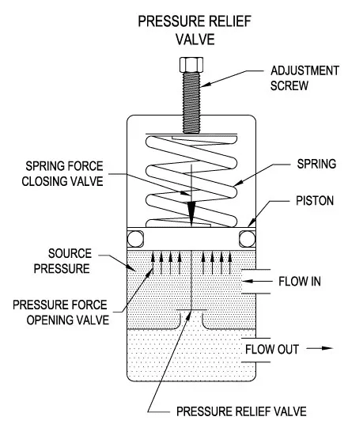

Figure 18: Basic components of a pressure relief valve. “The Basics of Pressure Relief Valves.” Beswick Engineering, 2023, www.beswick.com/resources/the-basics-of-pressure-relief-valves/.

### Air Vents

* How to vent air from glycol heating system
  1. Locate the manual air vents at high points in the system where air naturally collects. Common spots are near piping elbows and tees.
  2. Close the system isolation valves on the supply and return to restrict flow. Leave vent valves open.
  3. Slowly open the make-up water fill valve to pressurize the system to around 12 psi.
  4. One at a time, open each manual air vent to allow trapped air to escape until a steady stream of water flows out.
  5. Once water flows, close the air vent valve and continue venting at the other high point locations.
  6. Once all high point vents have been bled, open the isolation valves again for full system flow.
  7. Video content: <https://www.youtube.com/watch?v=z80WspC4Nmg>

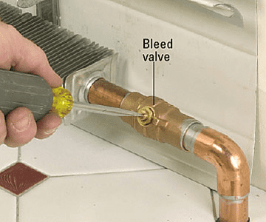

Figure 19: Two types if hydronic heating system bleed valves. Balancing Pumped Hot Water System, 3 May 2016, terrylove.com/forums/index.php?threads/balancing-pumped-hot-water-system.65473/.

* Air vents leaking glycol
  1. Check the glycol concentration with a refractometer. Adding water can dilute it, reducing boiling point. Top up to proper concentration if needed.
  2. Inspect the cap and seal on venting valves. Tighten cap or replace valve if worn out and not sealing properly.
  3. Make sure the system pressure does not exceed the vent's pressure rating, causing glycol to leak out. Lower pressure if over.
  4. Check that air vents are installed properly at system high points. Move to higher locations if placed incorrectly.
  5. Look for loose pipe connections allowing glycol seepage. Tighten fittings or replace leaky gaskets or seals.
  6. Flush the system to remove sediment buildup that could be holding open automatic air vent valves internally.
  7. Video content: <https://www.youtube.com/watch?v=pNuMMLhQDwQ>

Figure 20: Possible hydronic heating system design of bleed valve or air purge valve. Fine Homebuilding. “Purging Air in Hydronic Heating Lines.” Fine Homebuilding, 1 Jan. 2019, www.finehomebuilding.com/2018/11/09/purging-air-in-hydronic-heating-lines.

### Lift Pump

* Fuel lift pump not working (boiler will not come on)
  1. Check that the pump is getting electrical power by testing for power at the circuit breaker or fuse. Reset breaker or replace fuse if needed.
  2. Verify the electrical connections to the pump are intact and wires are not damaged or disconnected.
  3. Check for clogged fuel filters preventing flow to the pump inlet. Replace filter if dirty.
  4. Examine the pump couplings and shafts. Ensure they are intact and turn freely.
  5. Test the pump motor windings for open circuits or shorts using a multimeter. Replace motor if defective.
  6. Check for seized pump components or rust due to water ingress. Attempt to unstick or replace pump.
  7. Remove sediment or debris in the fuel oil storage tank that could be flowing into the pump. Filter or clean tank.
  8. Listen for pump motor hum indicating a locked rotor unable to turn. Attempt to turn shaft manually or replace if seized.
  9. If pump still fails to operate after checking these items, entire pump may need replacement by a qualified technician.
  10. Video content: <https://www.youtube.com/watch?v=NT6mMApZES0>

### Aquastat Relay

* Aquastat Relay makes a buzzing sound
  1. Check the aquastat control settings and verify it is calling for heat as expected based on temperature demand. Adjust settings as needed.
  2. Inspect the contacts on the aquastat relay and clean any pitted or corroded contacts.
  3. Tighten any loose wiring connections on the aquastat and at the control circuit terminal blocks.
  4. Test the transformer that powers the control circuit with a multimeter. Check for correct voltage. Replace if faulty.
  5. Look for signs of burned contacts on the relay indicating it needs replacement. Check for loose or vibrating armature.
  6. Verify relay is properly grounded. Buzzing can occur if it is ungrounded and energized.
  7. Make sure control circuit fuses or breakers are not blown or tripped. Reset or replace as necessary.
  8. Contact a technician to check if supply voltage to the aquastat is unstable. Solid state relay may be needed.
  9. Video content: <https://www.youtube.com/watch?v=BZJ2tch3_oc>
* Aquastat Relay: Boiler does not turn on/off as required
  1. Check aquastat settings match expected boiler temperatures for call for heat and shutdown. Adjust settings as needed.
  2. Inspect aquastat sensing bulb and capillary tube for damage. Replace aquastat if bulb or tube is broken or separated.
  3. Verify aquastat differential/deadband is properly set, not too wide to prevent burner shutdown. Adjust differential tighter if needed.
  4. Remove aquastat bulb and check it responds to hot and cold temperatures. Replace if unresponsive.
  5. Check for loose wire connections or faulty wiring between aquastat and boiler controls. Repair wiring if found.
  6. Bypass aquastat with jumper wire and test burner ignition. If ignition works, replace defective aquastat.
  7. Clean aquastat contacts if pitted or corroded. Chatter can disrupt control signal.
  8. Install new aquastat if cleaning contacts does not resolve. Select model with proper temperature range.
  9. Video content: <https://www.youtube.com/watch?v=tMVbmHl9iIw>

Figure 21: Possible Aquastat Relay configurations; refer to manual for your device. L, Evan. “C-Wire Connection to L8148A Aquastat.” Doityourself.Com, 1 Nov. 2012, www.doityourself.com/forum/thermostatic-controls/483052-c-wire-connection-l8148a-aquastat.html.

### High Limit & Cutoff Switch

* Bypassed or safety issue
  1. Locate the high limit cutoff switch, usually mounted near the thermostat controls or boiler jacket.
  2. Follow the wires from the cutoff switch to determine the normal circuit path.
  3. Check for any additional wires that are connected to the cutoff switch terminals that divert the circuit path.
  4. Examine wiring diagrams for the boiler controls to verify if the altered wiring bypasses the cutoff switch.
  5. Check boiler temperature and operation to determine if overheating is occurring due to the cutoff bypass.
  6. Carefully disconnect any jumper wires or wiring not original to the boiler controls that bypass the cutoff switch.
  7. Restore the original control circuit wiring path through the high limit cutoff switch terminals.
  8. Allow boiler to fully cool down before attempting to restart.
  9. Press the cutoff switch reset button once cooled and verify boiler ignites only below the high limit temperature threshold.
  10. Video content: <https://www.youtube.com/watch?v=sVpn-leIorM>

### Heat Recovery Ventilator

* Why you need it and what it does
  1. A heat recovery ventilator (HRV) complements your existing furnace or home heating system, increasing efficiency and helping your HVAC system reduce your energy bills. It works independently of your furnace and recycles the heat inside your home.
  2. An HRV is a mechanical ventilation device that exchanges air between the interior and exterior of a building.
  3. On heating boiler systems, the HRV provides controlled, balanced ventilation that replenishes indoor air.
  4. Inside the HRV are chambers that allow fresh incoming air and stale indoor exhaust air to pass next to each other without mixing.
  5. The fresh and exhaust airflows transfer heat and moisture between each other across heat exchanger membranes.
  6. In winter, the warmer indoor air preheats the cold incoming outdoor air without loss of interior heat.
  7. In summer, the cool incoming air helps reduce the temperature of the warm indoor air being exhausted.
  8. HRVs use two ducted air streams and fans to manage the balanced airflows.
  9. The airflows are filtered to clean incoming and exhaust air.
  10. Ventilation rates are adjusted via motorized dampers that modulate the air volume moved.
  11. HRVs connected to boilers provide fresh, tempered make-up air for proper burner combustion and indoor air quality.
  12. The HRV is a key component enabling boilers to provide both space heating and ventilation efficiently. Units should be maintained and filters changed regularly.
  13. Video content: <https://www.youtube.com/watch?v=i7US4TmyD6k>

Figure 22: What a heat recovery ventilator does. “Why a HRV / ERV Ventilation System Is a Smart Investment.” PrimexVents.Com, 5 Aug. 2014, www.primexvents.com/hrv-erv-ventilation-system-smart-investment/.

* Energy efficiency of heat recovery ventilator
  1. HRVs can be an energy-efficient way to provide necessary ventilation and air exchange in homes and buildings.
  2. The heat recovery core transfers thermal energy between air streams, retaining indoor conditioned air heat.
  3. This pre-heating of incoming air in winter reduces the boiler energy needed to reheat air to room temperature.
  4. Similarly, the HRV reduces air conditioning load in summer by pre-cooling warmer incoming air.
  5. Well-designed units can recover 60-80% of heating or cooling energy that would be lost through ventilation.
  6. HRVs run continuously, but variable speed motors and controls minimize electrical consumption.
  7. Newer HRV models also have very efficient ECM (electronically commutated) motors.
  8. When properly installed and controlled, HRVs can significantly increase the overall energy efficiency of a building relative to ventilation requirements. Regular maintenance is important.
  9. Video content: <https://www.youtube.com/watch?v=6ygifSRhh9A>

Figure 23: Household air circulation with an HRV. Linquip Team. “Heat Recovery Ventilation (HRV): Definition, Advantages & Installation.” Linquip Tech News, 3 Mar. 2023, www.linquip.com/blog/heat-recovery-ventilation-systems/.

* How to clean and change the filter
  1. Locate the filter access door on the side or back of the HRV unit. The door will be held closed by clasps or screws.
  2. Open the filter access door and slide out the old filter, checking the size and type. Make note for replacement.
  3. Check the filter direction arrows and orient the new filter accordingly as you slide it into place fully.
  4. Once the new filter is seated completely, close the access door and refasten any clasps or screws.
  5. Mark your maintenance schedule for when the next filter change is due based on hours of operation.
  6. Video content: <https://www.youtube.com/watch?v=DiaifXPDtaQ>
* How to adjust the wall sensor
  1. Locate the wall sensor, usually mounted in a central area of the home. It will have a small cover plate.
  2. Remove the sensor cover plate to access the adjustment dial or buttons underneath.
  3. Check the HRV settings and user manual to determine the desired temperature and humidity setpoints for the sensor.
  4. Use a small screwdriver to turn the adjustment dial or press the buttons to change the wall sensor's internal settings to the desired temperature and humidity setpoints.
  5. Replace the cover plate when finished adjusting settings.
  6. Allow time (hours) for readings to stabilize based on new settings before making further adjustments.
  7. The sensor readings should now match the setpoints programmed.
  8. Video content: <https://www.youtube.com/watch?v=yXcTj3wsya8>
* It is bringing cold air into the house
  1. Check if the issue occurs all the time or only during extremely cold weather. HRVs always bring in some cold fresh air.
  2. Verify the HRV core is transferring heat properly between the exhaust and fresh air streams. The inlet air should not be as cold as outside.
  3. Inspect the exterior hood termination for any blockages or damage allowing cold air leakage bypassing the core. Repair any issues.
  4. Make sure the HRV balanced dampers are tuned properly to the home's ventilation requirements. Adjust to minimum needed fresh air.
  5. Check that the defrost cycle is operating. Prolonged frost buildup on core can reduce heat transfer.
  6. Ensure ducting is properly insulated, especially supply ducts in unconditioned spaces like attics or garages. Add insulation as needed.
  7. Clean or replace HRV filters if excessively dirty. Built up dust reduces airflows.
  8. Consider upgrading to a unit with higher heat recovery efficiency if an older, inefficient model.
  9. Supplement with a downstream electric heater to temper excess cold inlet air if needed.
  10. Video content: <https://www.youtube.com/watch?v=6ygifSRhh9A>

### Fuel Storage Tank & Lines

* Annual maintenance (before freeze up)
  1. Inspect tanks, pipes, and containment for leaks, cracks, corrosion - repair as needed.
  2. Check tank, pipe, and line foundations and supports for settling – relevel.
  3. Ensure vents and overflow pipes are clear of obstructions.
  4. Lubricate and exercise valves to prevent sticking.
  5. Inspect and replace any damaged fuel lines.
  6. Insulate exposed pipes and install heat trace as needed.
  7. Drain water, sediments from tanks and filters.
  8. Treat diesel with anti-gelling additives.
  9. Top off tanks and arrange fuel deliveries before winter.
  10. Test tank gauges, leak detection, and alarm systems.
  11. Video content: <https://www.youtube.com/watch?v=dns4ALjcbgY>

Figure 24: Sample fuel tank inspection checklist. “Tank Inspection.” MOYER, EMOYER Services, 2023, emoyer.com/services/heating-fuel/oil-tank-inspection/.

* Fuel line inspection
  1. Visually inspect all fuel lines for cracks, leaks, corrosion, or damage. Look for signs of weeping or dripping.
  2. Check pipe supports are solid with no settling. Resecure any loose pipe hangers.
  3. Ensure valves turn freely and are not stuck. Exercise valves from fully open to closed.
  4. Verify fuel line vents and caps are clear from debris or obstructions.
  5. Check pipe insulation for any missing sections or deterioration. Replace if damaged.
  6. Inspect pipe joints for seepage or drips. Tighten fittings or reseal leaking joints.
  7. Follow all lines from tank to appliance connections checking for issues. Look for signs of surface rust.
  8. Video content: <https://www.youtube.com/watch?v=AGUlGmfzxx4>

### Homes Without Municipal Water & Sewer

* Water pump & tank inspection
  1. Check water tank exterior for corrosion, leaks, or cracks. Look for signs of overflow.
  2. Verify water pump turns on and builds adequate system pressure by opening faucets.
  3. Listen for unusual pump noises like grinding or knocking which could indicate issues.
  4. Inspect electrical connections to pump for damage. Make sure cover is secure.
  5. For submersible pumps, check power cable and pipe/wire entries are watertight.
  6. Clear debris from around pump inlets. Make sure inlets are not obstructed.
  7. Check pressure tank water-air bladder by verifying proper air charge. Add air if pressure is low.
  8. Lubricate pump motor if required per manufacturer instructions.
  9. Test checking valve by verifying water does not backflow when pump shuts off.
  10. Video content: <https://www.youtube.com/watch?v=GaLiYCaHq4Y>

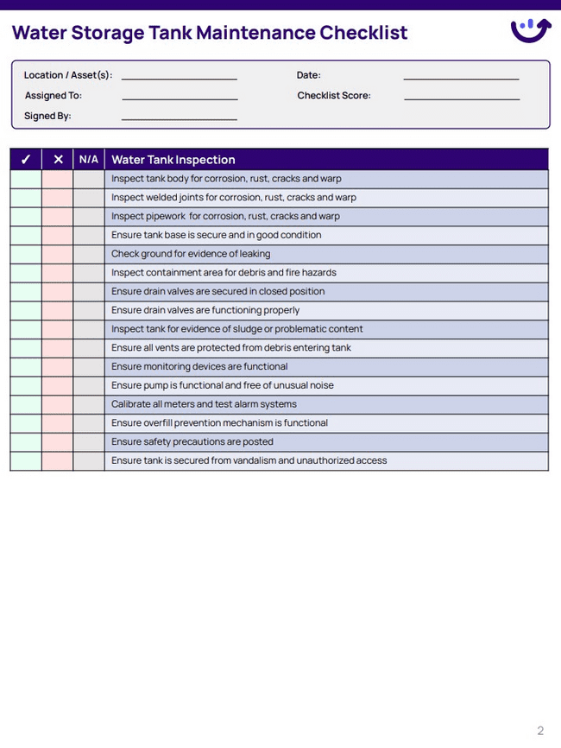

Figure 25: Sample water storage tank checklist. “Water Storage Tank Maintenance Checklist.” Xenia.Team, xenia, 2023, www.xenia.team/templates/water-storage-tank-maintenance-checklist.

* Sewer holding tank inspection
  1. Check tank exterior for leaks, cracks, or corrosion damage. Look for signs of overflow.
  2. Inspect tank lid seal for any cracks or deterioration that could allow odors to escape.
  3. Verify vent pipe is clear and screened to prevent clogging and allow gases to escape.
  4. Evaluate inlet and outlet piping condition and check for any blockages or leaks.
  5. Measure sludge and scum levels with a tank gauge stick. Arrange pumping if near full.
  6. Check alarm float switches and controls are functioning properly to indicate high levels.
  7. Inspect condition of access covers and risers. Ensure lids fit properly and seals are intact.
  8. Clear any debris or obstructions around exterior tank vents or manholes.
  9. Check surrounding soil for indication of leaks like odors or soggy areas.
  10. Video content: <https://www.youtube.com/watch?v=fIYuv832zTs>

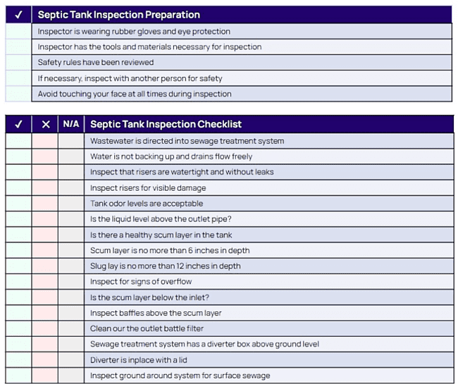

Figure 26: Sample septic tank inspection checklist. xenia. “Septic Tank Inspection Checklist.” Xenia.Team, Xenia, 2023, www.xenia.team/templates/septic-tank-inspection-checklist.

# Exterior of Home

## Porches & Railings

* Stair treads or porch stiles missing (hazardous condition)
  1. Assess damage: Check if riser, nosing, or entire tread is broken. Note which treads are affected.
  2. Match materials: Obtain same wood type and size for replacement treads.
  3. Remove broken pieces: Carefully pry/cut out remnants of damaged tread and risers.
  4. Cut new tread: Measure rise and run, cut replacement tread to size.
  5. Install new tread: Predrill holes, use wood glue and nails/screws to secure.
  6. Sand and finish: Sand new tread flush, match stain or paint to existing.
  7. Test repairs: Carefully check each tread for solid attachment and smooth run.
  8. Video content: <https://www.youtube.com/watch?v=RnQOaz_L-Ms>
* Steps or porch are out of level (caused by settling or erosion)
  1. Check for loose joints: Inspect where stringers meet treads and risers for any looseness. Tighten if needed.
  2. Look for settling: See if the whole stair frame has shifted or just certain treads.
  3. Determine if load-bearing: Check if the stairs support any structural weight above. This affects repair approach.
  4. Evaluate materials: Assess if treads and risers are wood, concrete, or other material.
  5. Shim any gaps: Use shims to remove gaps between treads and stringers if present.
  6. Sand or plane high spots: Carefully sand or plane down any treads higher than others.
  7. Build up low treads: Use wood filler or shims to raise any treads lower than others.
  8. Recheck level: Confirm all treads are even after adjustments using a level tool.
  9. Refasten if needed: Secure any loose treads with new glue, nails, or screws.
  10. Paint or finish repairs: Apply matching paint or stain to refreshed areas.
  11. Video content: <https://www.youtube.com/watch?v=Ogx23KgSs5E>

## Exterior Lighting (Porch Lights)

* Burned out light bulbs
  1. Turn off power - Locate the circuit breaker powering the exterior light and switch it to the "off" position.
  2. Remove cover - Take off the outer glass or plastic cover over the light bulb by unscrewing or releasing any retaining clips.
  3. Replace bulb - Unscrew the old light bulb and properly dispose of it. Install a new bulb of the correct type and wattage by screwing it securely into the socket.
  4. Replace cover - Carefully put the protective cover back over the light bulb and screw or snap it back into place.
  5. Restore power - Flip the circuit breaker back to the "on" position to restore power and test the new bulb.
  6. Video content: <https://www.youtube.com/watch?v=jdFkkorEqIM>
* Fixture damaged or inoperable
  1. Burned out bulb - Replace the light bulb with a new one of the correct type and wattage.
  2. Tripped breaker - Check the circuit breaker box for a tripped breaker controlling the outdoor light and reset it.
  3. Failed sensor - For fixtures with motion sensors, the sensor may need replacement if it no longer triggers the light.
  4. Corroded wires - Check wires and connections for corrosion and have an electrician repair or replace damaged wiring.
  5. Bad transformer - For low voltage systems, the transformer may have failed and need replacement by a technician.
  6. Damage from weather - Impact from storms or water infiltration can damage fixtures. Inspect and repair or replace the entire fixture.
  7. Timer or photo eye issues - For lights on timers or photo sensors, reset the programming or replace defective parts.
  8. Video content: <https://www.youtube.com/watch?v=xpb3a0fjqU4>
* Exposed electrical wiring
  1. Inspect - Visually inspect wiring for damage. Look for nicks, exposed copper, burn marks, cracked insulation. Also check connections are tight.
  2. Replace damaged wiring - Any cables too damaged to repair should be completely replaced with new wiring of proper gauge and insulation.
  3. Splice repairs - Use weatherproof splice kits to reconnect severed wires. Follow kit instructions carefully for waterproof connections.
  4. Test circuits - Turn power back on and test lights and receptacles the wiring feeds. Verify proper operation.
  5. Insulate and seal - Use electrical tape and waterproof sealant on any splices or connections to protect from moisture.
  6. Check grounding - Ensure exposed exterior wiring maintains proper grounding to avoid shocks and surges.
  7. Preventative improvements - Consider running wiring through conduit to add an extra layer of mechanical and weather protection.
  8. Video content: <https://www.youtube.com/watch?v=LjE1OLKQN0w>
* Missing light lens covers
  1. Disconnect power - Locate the circuit breaker controlling the lamp and turn it OFF for safety.
  2. Interim replacement - Until replacement found, possible interim replacements are: plexiglass, glass bowl, electrical box splash guard.
  3. Remove old lens - Unscrew or loosen any brackets or retention screws holding the lens frame in place and detach the damaged old lens.
  4. Install new lens - Align the new replacement lens frame in the fixture opening and reattach using screws or retention clips.
  5. Restore power - With the new lens securely installed, flip the circuit breaker back ON to restore power.
  6. Test operation - Ensure the light turns on and off correctly. Check for any gaps in the lens frame seal.
  7. Video content: <https://www.youtube.com/watch?v=Hbf42VwgU6M>

## Exterior GFCI Outlets

* Exterior fixtures not working (how to reset a GFCI outlet)
  1. Check breaker - Verify the breaker supplying the outlet is switched on and not tripped. Reset if needed.
  2. Press reset button - Outdoor GFCI outlets have a weatherproof reset button that may need to be pressed to restore power if tripped.
  3. Check for moisture - Look for any water or moisture inside the outlet box or on wires that may have tripped the GFCI. Dry thoroughly.
  4. Test with GFCI tester - Plug in a GFCI tester and press test. If it doesn't trip or doesn't reset, the GFCI needs replacement.
  5. Inspect connections - Switch off breaker and remove outlet to inspect all wire connections are secure and free of corrosion.
  6. Check for damaged wires - Look for any nicks, exposed wire, or cracked insulation that could be grounding out power.
  7. Replace GFCI - Faulty or water damaged GFCIs should be replaced with a new weatherproof exterior rated model.
  8. Verify grounding - Ensure the outlet box and wires have proper grounding connections.
  9. Video content: <https://www.youtube.com/watch?v=RQWFyj_OzEE>
* Missing outlet covers
  1. Turn off power - Locate the circuit breaker controlling the outlet and switch it to OFF for safety.
  2. Remove old cover - Unscrew the existing weatherproof cover to remove it from the outlet box.
  3. Check outlet condition - Inspect the receptacle for any signs of damage, moisture, or wear needing repair.
  4. Install new cover - Align the new gasketed exterior cover over the outlet box holes. Attach securely with the cover screws.
  5. Restore power - Flip the circuit breaker back to ON. Test the outlet and check for secure closure with the new cover.
  6. Video content: <https://www.youtube.com/watch?v=qHtVU0_1IBI&t=306s>
* Exterior outlet box hanging from side of home (exposed wires)
  1. Turn off power at circuit breaker and inspect for damage. Replace any frayed wiring.
  2. Remove receptacle, tape/cap wires, detach box from siding.
  3. Scrape away old caulk and debris, clean area for new box.
  4. Install new exterior GFCI box matched to siding. Run wires through box, attach securely.
  5. Connect wires to new receptacle, attach to box. Install cover, test outlet before reconnecting power.
  6. Video content: <https://www.youtube.com/watch?v=pSgGPYM8sfo>

## Foundation Out Of Level

* Consequences of melting permafrost on home level
  1. Bering Straits homes are built on pad and post foundations to help reduce homes shifting. But permafrost melt still occurs due to increasing climate temperatures, causing home foundation shifting.
  2. When the permafrost melts, foundation posts sink into the ground (differential settlement). This causes the entire home to go out of level.
  3. Symptoms will increase from misaligned doors and windows, to glass breaking, to wall cracks and increasing drafts.
  4. One inexpensive method to determine the level of a home is with a water-level. See below:
  5. Video content: <https://www.youtube.com/watch?v=KgNe2GLRcfo>
* How to level your home
  1. Assess the current level and tilt of the home. Use a level tool (water level, spirit level, laser level, etc.) to determine which corners or sides have dropped and by how much.
  2. Carefully raise the needed areas using jacking posts. Work incrementally in small lifts, checking the level frequently to avoid over-correcting. Lifting too much in one area could make things worse.
  3. If posts cannot be raised further, place solid spacers underneath to gain needed height (e.g. thick treated lumber). Secure spacers well.
  4. For posts that have "settled" and no longer contact the beam above, add shims/wedges to re-establish contact and load transfer.
  5. Allow time after lifts and adjustments for the home to settle in before rechecking level. Make incremental adjustments until within acceptable tolerance.
  6. Inspect for damage that may have occurred during the leveling process, like cracked drywall or separated frames. Make repairs as needed.
  7. Consider adding extra insulation or heat tape around posts/foundations as preventive measures against further thawing and settling.
  8. Periodically recheck levels and make minor adjustments over time.
  9. Video content: <https://www.youtube.com/watch?v=Vq0FA-H21Dk>
* Foundation Rust Causes
  1. Constant humidity and dampness from thawing ground: Improve drainage and moisture barriers.
  2. Ocean salt spray or road salt exposure: Move away from ocean or roads.
  3. Insufficient cleaning, drying, and recoating of pilings: Maintain protective coatings.
  4. Older pilings losing protective coatings over time: Reapply coatings regularly.
  5. Scraping against ground wears away protective coatings: Add barrier between piling and ground.
  6. Low-grade, thin metals corrode faster than high-quality steel: Use high-grade materials.
  7. Increased moisture from sinking into thawing permafrost: Insulate pilings from ground warmth.
  8. Galvanic corrosion between dissimilar metals contacting: Separate dissimilar metals.

## Erosion & Damage

* Water from roof eroding around home
  1. Install rain gutters and downspouts to capture roof water and redirect it away from the house foundation through underground pipes or hoses.
  2. Build up the ground with gravel, crushed stone, or retaining walls to divert water flow away from the foundation.
  3. Plant native shrubs, trees, and grasses around the house to help absorb runoff and stabilize the soil. Avoid planting too close to the foundation.
  4. Use landscaping techniques like berms, swales, terraces to redirect the flow of water around and through the property.
  5. Cover bare soil areas with mulch, grass, erosion control blankets or mats to protect from direct water contact and runoff.
  6. Video content: <https://www.youtube.com/watch?v=OoFoyuiUrso>
* Soil washed or blown away
  1. Install downspout extenders or flexible piping to redirect roof water flow far away from the house to prevent soil erosion nearby.
  2. Construct lined drainage channels, swales, or berms to capture runoff and guide it safely to a collection area.
  3. Use rain chains instead of downspouts to gently disperse water and reduce impact on underlying soil.
  4. Plant native grasses, shrubs or trees in areas vulnerable to water and wind erosion to stabilize the soil with roots.
  5. Cover bare ground around the home with erosion-control mats, gravel, or wood mulch to protect soil from direct water contact.
  6. Build terraced retaining walls or raised garden beds to break up and contain rainfall before it picks up speed down slopes.
  7. Ensure proper grading slopes water away from the house and prevents it from pooling near soil.
  8. Video content: <https://www.youtube.com/watch?v=GcvAGadSE6Q>

## Electrical Ground Rods

* Correct ground rod installation and connection
  1. Berring Straight homes require two connected ground rods.
  2. Inspect that there are two ground rods spaced at least 6 feet apart.
  3. Verify each rod is driven fully into the earth, leaving no more than 4 inches exposed.
  4. Check that the ground rods are connected to each other by a properly sized buried grounding electrode conductor.
  5. Confirm the grounding electrode conductor is securely attached to each ground rod by suitable clamps or welding.
  6. Measure that the total resistance to ground is 25 ohms or less using a earth ground resistance tester.
  7. Visually inspect that ground clamps show no sign of corrosion and are tightly secured.
  8. Trace the grounding electrode conductor to confirm it connects properly to the main electrical service grounding system.
  9. Video content: <https://www.youtube.com/watch?v=DiapZ7RkjFc>

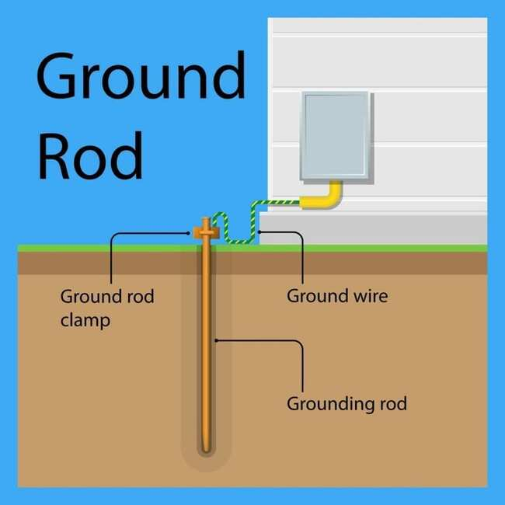

Figure 27: Typical grounding rod configuration. “What Is Electrical Grounding?” Way Point Property Inspection, LLC., waypointinspection.com, 2023, waypointinspection.com/what-is-electrical-grounding/.

* Broken or rusted ground rods
  1. Visually inspect the ground rod if possible - Look for obvious damage like the rod being bent, cracked, or uprooted.
  2. Check ground resistance - Use a earth/ground resistance tester. A high reading over 25 ohms may indicate a disconnected or damaged ground rod.
  3. Inspect ground wire connections - Check if the ground wire connections to the rod are corroded or loose which could cause intermittency.
  4. Follow ground wire path - Ensure the ground wire is intact and connected back to the main panel and not damaged.
  5. Measure continuity - Use a multimeter set to continuity test mode to check for continuity between the ground rod and ground wire. No continuity points to a break.
  6. Listen for arcing - If able to safely isolate power, listen closely to the ground system for any arcing sounds which could mean a loose, corroded, or detached point in the ground path.
  7. Consider environmental factors - Nearby digging, landscape work, etc. may have damaged an underground section of the ground rod or wire.
  8. Video content: <https://www.youtube.com/watch?v=G2OtgeDkTLs>
* Corroded ground rod clamps
  1. The clamp is typically made of galvanized steel, copper, or other conductive metal that can corrode over time when exposed to moisture and dirt.
  2. Corrosion causes the metal to oxidize and build up resistance, which reduces the effectiveness of the connection to ground.
  3. Visible signs of corrosion include green/white oxidization, pitting, flaking, cracking, or staining on the clamp surface and wires.
  4. Looseness, gaps, or high resistance can indicate the clamp contact area has corroded away and no longer makes consistent contact with ground rod.
  5. A severely corroded clamp may completely fail by falling apart when handled or may no longer conduct electricity safely to ground.
  6. Corroded clamps need to be repaired by thoroughly cleaning off oxidation.
  7. Reduce corrosion by re-tightening clamps, greasing threads, and recoating clamp surfaces.
  8. Video content: <https://www.youtube.com/watch?v=Q1ElcTLa9NM>

## Electrical Meter Base & Mast

* What is an open neutral or open leg
  1. If you have the symptoms below, call an electrician or power plant operator.
  2. Positive voltage reading from a neutral wire.
  3. Electrical shock when contacting a neutral wire.
  4. 120V outlets working, 240V appliances not working - With only one hot leg working, standard 120V circuits may seem fine while larger 240V appliances like ovens, AC units, and dryers won't function.
  5. Dimming or flickering lights - As the neutral connection opens and closes, lights will dim or fluctuate in brightness as power flow is disrupted.
  6. Appliances not working - Open neutrals can disable appliances if they are unable to complete the circuit.
  7. Overheating wires - Electricity will seek any path to return, which can cause wires to overheat without a proper neutral connection.
  8. Tingling sensations - If you come in contact with appliances where electricity finds an alternate return path, you may feel tingling or shock sensations.
  9. Circuit breakers tripping - The imbalance in power may continually trip circuit breakers as electricity flows erratically. <https://www.hunker.com/12436135/what-is-an-open-neutral>
  10. Video content: <https://www.youtube.com/watch?v=RsuezfpA-Po>
* Overloaded electrical circuits tripping breakers
  1. Too many appliances on one circuit - Redistribute devices over additional circuits to balance the load.
  2. Faulty appliances - Malfunctioning appliances like damaged motors can overload and trip circuits. Inspect and repair or replace faulty devices.
  3. Loose wiring - Loose wire connections create resistance and overheating that trips breakers. Have an electrician inspect.
  4. Undersized wiring - Outdated wiring that is too small gauge for modern power demand will overheat when overloaded. Upgrade wiring.
  5. Too many extension cords - Chaining too many extension cords together overloads circuits. Reduce usage.
  6. Major appliances on small circuits - Heavy appliances need dedicated circuits. Don't combine with lighting, outlets on 15-20 amp circuits.
  7. Bad breaker - Excessively tripped circuits may indicate a faulty breaker in need of replacement by an electrician.
  8. Short circuit - Damaged wires touching and shorting can instantly trip a breaker. Inspect wires for damage or improper connections.
  9. High-wattage bulbs - Large 300-500 watt incandescent bulbs can overload lighting circuits. Switch to lower wattage LED bulbs.
  10. Electric space heaters - High-draw portable heaters should not share circuits with other devices. Dedicate circuit just for the heater.
  11. Video content: <https://www.youtube.com/watch?v=jl8Dn3I54K8>
* Corroded electrical enclosures
  1. If these symptoms spotted, identify and reduce the source of corrosion. Consult your power plant operator and consider switching to stainless steel electrical enclosure.
  2. Rust spots - Visible rust stains or oxidation around metal junction boxes, conduit, and panel covers signifies corrosion.
  3. Swelling or cracks - Water can make enclosures swell or crack over time leading to serious structural issues.
  4. Corroded wiring - Moisture causes copper wiring to oxidize, reducing conductivity and overheating connections.
  5. Shocks - Corroded surfaces conduct electricity easier leading to potential shocks from exposed metal.
  6. Fire hazard - Severe corrosion can degrade connections leading to short circuits, arcing faults or even open flames inside panels.
  7. Video content: <https://www.youtube.com/watch?v=MWzA1m52Gco>
* Broken weatherheads and missing covers
  1. De-energize the wires - Have the power company disconnect electrical service at the pole and meter. Verify wires are de-energized.
  2. Remove damaged weatherhead - Unscrew any damaged conduit fittings to detach the old weatherhead for replacement.
  3. Clean conduit ends - Sand and file the cut conduit ends to clean smooth edges for reconnection.
  4. Install new weatherhead - Thread new weatherhead onto the conduit ends protruding from the roof/mast. Tighten securely.
  5. Reconnect wires - Feed the utility wires back through the new weatherhead and reconnect leads with proper connectors.
  6. Caulk seals - Caulk around conduit and weatherhead to create a watertight seal against the elements.
  7. Restore power - Notify the utility company to re-establish service connection and restore electrical power.
  8. Video content: <https://www.youtube.com/watch?v=VtmdrY3ZqaY>

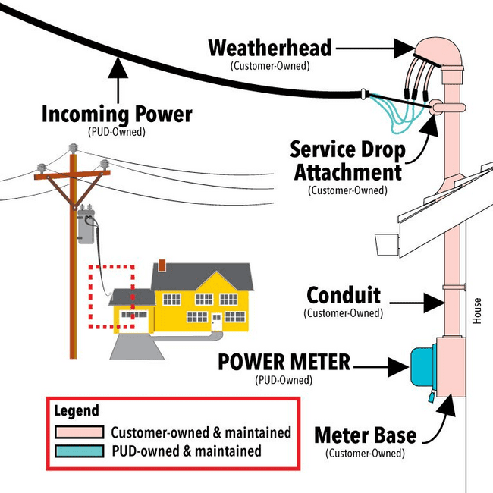

Figure 28: Common electrical utility system design, with weatherhead. “What’s That? Weatherhead & Service Drop.” Jefferson County Public Utility District, Jefferson County, 2023, www.jeffpud.org/whats-that-weatherhead-service-drop/.

## Chimneys & Chimney Braces

* Damaged by snow
  1. Visually inspect the exterior of the metal chimney for dents, damage, or separated joints/sections.
  2. Check the interior flue for obstructions using a chimney inspection camera if possible.
  3. Remove any debris or obstructions from the metal flue using chimney cleaning rods or brushes.
  4. For dented or crushed sections, use a hammer or pliers to gently reshape the metal back into round shape. Replace severely damaged sections.
  5. Separated chimney joints can be resealed using high temperature silicone or chimney sealant. Resecure any detached sections.
  6. Add additional external support straps or metal braces if needed to stabilize or support damaged areas.
  7. Consider adding a chimney cap to prevent water intrusion.
  8. Do a final inspection and test for proper draft before using the stove again.
  9. Video content: <https://www.youtube.com/watch?v=poxmuAeKN1w>
* Fallen over after high winds
  1. Carefully inspect the chimney pipe for any cracks, splits, or other damage caused by the impact of falling over. Minor dents can be hammered out, but cracked sections will need replacement.
  2. Reattach any sections of chimney pipe that have separated at the joints. Use sheet metal screws and/or high-temperature sealant to securely fasten the joints.
  3. Standing on a ladder or roof, lift the chimney pipe back into proper vertical position. It may help to have a helper hold the bottom steady.
  4. Re-secure the chimney brackets that hold the pipe to the side of the house. Use new brackets if the originals are damaged. Space brackets every 5-6 feet for proper support.
  5. Install guy wires or chimney support straps if needed to provide additional bracing and prevent the pipe from falling again. Anchor these well to the roof.
  6. Double check that all sections are reconnected properly with no leaks. Perform a smoke test to check draft.
  7. Consider adding a wind-resistant chimney cap specially designed for high wind areas.
  8. Inspect the interior of the stove pipe and chimney using a camera for any internal damage before using again.
  9. Video content: <https://www.youtube.com/watch?v=bHMhCzuSe8g>
* Chimney cap missing
  1. Use a chimney brush and rods to sweep out any debris from the top of the chimney pipe before removing the chimney cap. This will prevent debris from falling into the stove pipe.
  2. Use a Phillips screwdriver to remove any screws securing the damaged chimney cap. Some caps may be secured with bolts instead, in which case use the appropriate wrench.
  3. Wearing thick gloves, lift and remove the damaged chimney cap. Lower it safely to the ground.
  4. Inspect the top of the chimney pipe for any damage or rust. Scrape off loose paint or rust and repaint if needed.
  5. Place the new chimney cap on top of the chimney pipe, aligning any holes for screws.
  6. Reinstall screws or bolts to securely fasten the new cap, using hand tools or a power drill.
  7. Seal any gaps between the cap and pipe with high temperature waterproof silicone sealant.
  8. Perform a visual inspection to ensure the new chimney cap is properly aligned and secured before using the wood stove.
  9. Video content: <https://www.youtube.com/watch?v=vvmJYouduww>

## Roofing

* Water leaks inside the home
  1. Visually inspect the metal roof, looking for corrosion, cracks, or holes where water could be penetrating. Mark any problem areas.
  2. Use a hose to spray water on the roof and pinpoint where exactly it is leaking through. Have someone inside watch where water comes in.
  3. For small holes or cracks, clean and sand the area, then apply a metal patch sealant or roof sealant. Smooth to blend.
  4. For larger cracks or leaks, use a grinder to open the area into a wide V-shape. Apply sealant into the V-crack, then bolt a metal flashing piece over it.
  5. Check areas where sheets meet or overlap for separated seams. Use butyl sealant in between and add new fastener screws along the seams.
  6. For leaks around vents, chimneys, etc. re-caulk with a flexible metal roof sealant. Consider adding flashing pieces around the edges.
  7. Use roofing screws to secure any loose or curving metal panels that could be leaking when water pools on them.
  8. For severe leaks or damage, professional repair or full panel replacement may be required.
  9. Video content: <https://www.youtube.com/watch?v=T9IefLMNZnU>
* Parts of the roof loose or blown off
  1. Identify and assess the damaged areas - look for missing panels, sections, or tiles as well as any still partially attached but loose.
  2. Wearing gloves, carefully remove any remaining loose sections or debris.
  3. Inspect the roof deck and sheathing for rot or water damage. Replace any damaged decking.
  4. Cut replacement metal panels to size as needed using tin snips. Match original metal thickness and profile.
  5. Position the new metal panels in place, aligning any edges with existing panels. Drill pilot holes as needed.
  6. Using neoprene grommets, fasten the new panels into place with metal roofing screws. Follow manufacturer specs for screw type and spacing.
  7. Seal and reinforce all seams using metal seam tape, sealant, and additional screws along seams.
  8. Inspect flashing around vents, pipes, etc. Reseal any as needed with metal roof sealant.
  9. Consider adding metal wind clips, straps, or brackets for extra wind resistance.
  10. Video content: <https://www.youtube.com/watch?v=cRWZWcVqhIs>

## Walls & Siding

* Siding damaged / pieces missing
  1. Prepare the area - Remove any remaining damaged siding pieces and debris. Inspect the underlying house wrap/sheathing for damage and repair as needed.
  2. Measure and cut replacement siding - For wood siding, cut new boards to size to match existing. For vinyl, cut with snips to fit.
  3. Install starter strip - If needed, nail new metal starter strip along the bottom, level with the existing siding.
  4. Attach the new siding - Align the new piece with the surrounding siding. Nail wood boards into the studs or use adhesive for vinyl.
  5. Fill seams - For wood siding, use exterior wood filler along the seams and sand smooth. For vinyl, use vinyl cement.
  6. Paint or finish - For replaced wood siding, prime and paint using exterior grade paint to match existing. Vinyl may not need painting.
  7. Caulk edges - Once dry, caulk all seams between new and existing siding with exterior acrylic caulk. Smooth for water seal.
  8. Video content: <https://www.youtube.com/watch?v=lzhSsmWnHfw>

## Eaves & Soffits

* Air leaks into attic (soffit vents)
  1. Inspect soffit vents from inside the attic - Use a flashlight to look for daylight or debris coming through vent openings indicating gaps.
  2. Check vent seals - Run your hand along edges to feel for gaps or cracks in the vent housing, screens, or covers.
  3. Seal vents with caulk - Use exterior silicone or acrylic caulk to seal around vent openings and seams. Avoid blocking needed ventilation.
  4. Stuff insulation in large gaps - For larger gaps, stuff fiberglass insulation or steel wool to fill before caulking over.
  5. Install baffles - Position insulation baffles between roof rafters directing airflow from vents into the attic space.
  6. Air seal attic floor penetrations - Seal gaps around wires, ducts, and other openings in the attic floor to prevent air leakage.
  7. Consider professional foam insulation - For widespread gaps that are hard to locate, hiring a pro to spray foam major air leakage areas may be needed.
  8. Video content: <https://www.youtube.com/watch?v=zaaaVfjdYnQ>

## Rain Gutters

* Damaged by snow
  1. Assess the damage - Look for bent, misaligned, or detached sections of gutter. Check for cracked seams or holes leaking water.
  2. Remove debris - Clean out built up debris from gutters using a small trowel or gutter cleaning scoop.
  3. Straighten or rehang - Use pliers or a rubber mallet to straighten any bent gutters back into shape. Re-hang detached sections.
  4. Patch holes - Use gutter sealant or patch kits to seal over any small holes or leaks. Larger holes may need gutter replacement.
  5. Seal seams - Dry fit cracked gutter seams back together. Clean seam areas then apply gutter seam sealer for waterproof bond.
  6. Add support braces - Install new gutter support braces spaced 3-4 feet apart to prevent sagging and detachment.
  7. Slope and pitch - Adjust hangers so gutters slope 1/4 inch per 10 feet to properly drain water.
  8. Reinforce with screws - Add exterior screws along gutter seams and to connect gutters to eaves for added stability.
  9. Consider gutter guards - Adding gutter guards can prevent snow and ice buildup from causing strain and damage.
  10. Video content: <https://www.youtube.com/watch?v=aPmaRQwAeF0>
* Down spouts missing / damaged
  1. Assess the damage - Look for bent, misaligned, or detached sections of gutter. Check for cracked seams or holes leaking water.
  2. Remove debris - Clean out built up debris from gutters using a small trowel or gutter cleaning scoop.
  3. Straighten or rehang - Use pliers or a rubber mallet to straighten any bent gutters back into shape. Re-hang detached sections.
  4. Patch holes - Use gutter sealant or patch kits to seal over any small holes or leaks. Larger holes may need gutter replacement.
  5. Seal seams - Dry fit cracked gutter seams back together. Clean seam areas then apply gutter seam sealer for waterproof bond.
  6. Add support braces - Install new gutter support braces spaced 3-4 feet apart to prevent sagging and detachment.
  7. Slope and pitch - Adjust hangers so gutters slope 1/4 inch per 10 feet to properly drain water.
  8. Reinforce with screws - Add exterior screws along gutter seams and to connect gutters to eaves for added stability.
  9. Consider gutter guards - Adding gutter guards can prevent snow and ice buildup from causing strain and damage.
  10. Video content: <https://www.youtube.com/watch?v=19nnzT8Orjs>

## Arctic Boxes & Utilidors

* Falling off the side of the home
  1. Assess the damage - Check for broken, loose, or corroded mounting hardware causing the separation from the house. Also look for rot or deterioration of the wall structure.
  2. Shore up or support the Arctic Box temporarily using braces or jacks until repairs can be made.
  3. Remove any remaining loose hardware or damaged pieces of the mounting frame.
  4. Reinforce the wall structure - Add plywood, timbers, or a metal plate to reinforce the area and provide solid attachment.
  5. Fabricate and install new mounting frame - Use treated lumber in this wet environment. Attach firmly to wall reinforcing.
  6. Carefully lift and reposition the Arctic Box onto the new frame. Have helpers to lift safely.
  7. Bolt through the Arctic Box frame into the new mounting frame using stainless steel hardware. Apply sealant around bolts.
  8. Check that all plumbing, electrical, and sewer connections are still intact. Detach and re-mount any that are damaged or have come loose.
  9. Test systems thoroughly before returning the Arctic Box to full service.
  10. Video content: none found
* Damaged insulation
  1. Assess area and remove debris - Clear away any loose, damaged insulation pieces from the utilidor exterior.
  2. Prep surface - Use scrapers, brushes, or pressure washers to remove any remaining adhesive, staples, or fasteners from the utilidor walls.
  3. Measure space - Measure the total square footage needing new insulation. Account for any pipes, wires, or obstructions on the walls.
  4. Cut insulation - Use a utility knife to cut rigid foam board or batt insulation to fit the utilidor walls snugly. Get proper thickness and R-value.
  5. Install vapor barrier - Staple polyethylene sheeting or other vapor barrier material over insulation area.
  6. Attach insulation - Use construction adhesive and/or screws with washers to firmly adhere insulation over vapor barrier. Seal seams with tape.
  7. Weatherproof - Caulk around edges and seams using exterior caulking. Apply weather resistant barrier like house wrap over the top.
  8. Inspect and repair cladding - Replace any damaged metal siding or other exterior cladding.
  9. Check for drafts - Conduct an interior inspection to ensure no air leaks around utilidor entrance points. Weatherstrip as needed.
  10. Video content: none found

# Health & Safety

## Bedbugs & Other Pests Detected

* Bedbugs detected in bed and carpet
  1. To prevent bed bugs, inspect used furniture, clothing or beds before bringing into house. Be cautious when putting belongings down in not well kept hotels or homes.
  2. Detect bed bugs by looking for live bugs, blood and fecal stains on sheets, mattress seams, crevices, folds, and furniture.
  3. Remove by washing all bedding and clothing in hot water and dry on high heat to kill bugs and eggs.
  4. Vacuum mattresses, furniture, and surrounding floor areas thoroughly to remove bed bugs, and dispose of vacuum bag immediately outside.
  5. Apply residual insecticide sprays or powders in cracks, crevices, baseboards, and around beds.
  6. Use heat treatment or steamers to kill bugs and eggs on furniture, carpets, and hard to reach areas. Temperature must reach 120°F.
  7. Seal cracks and crevices where bugs can hide with caulk and sealants.
  8. Encase mattresses and box springs in bed bug proof covers to trap bugs inside. Leave on for at least a year.
  9. Treat surrounding rooms and spaces near the infested areas to halt spreading.
  10. Video content: <https://www.youtube.com/watch?v=Ik6ZVe1YXlo>

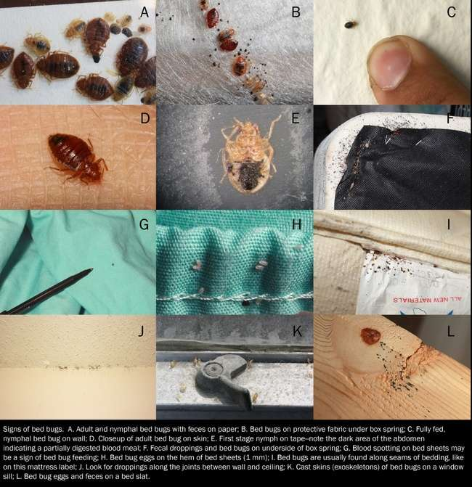

Figure 29: Twelve signs of bedbugs. “Recognizing Bed Bugs and Their Signs.” Insects in the City, Texas A&M AgriLife Extension, 2023, citybugs.tamu.edu/factsheets/biting-stinging/bed-bugs/ent-3015/.

* Other insects detected
  1. Prevent by sealing cracks, crevices and openings around windows, doors, pipes, vents etc. where bugs can enter. Use caulk, weather strips, screen material.
  2. Prevent by keeping exterior doors shut and use door sweeps.
  3. Prevent by keeping foliage, shrubs, and mulch away from the house exterior.
  4. Remove by vacuuming and sweeping dirt and pests. Bag & dispose immediately.
  5. Use baits and traps specific to the insect type. Place them along walls and common pathways.
  6. Video content: <https://www.youtube.com/watch?v=05GHwaE6ocA>
* Mice and rodent detected in walls and attic
  1. Place bait stations and traps along walls and in attic access areas. Check and refresh bait frequently.
  2. Look for rub marks, droppings, nests or damage to locate infestation points for targeted baiting.
  3. Seal any interior and exterior holes, cracks or openings larger than 1/4 inch that allow rodent entry. Use steel wool, caulk, wood, metal kick plates.
  4. Store human and pet food in sealed metal or glass containers to limit smells that attract rodents. Clean up crumbs and spills off floor.
  5. Video content: <https://www.youtube.com/watch?v=2lxhD5wnhXk>
* Birds detected in eaves and attic
  1. Install bird netting over eave openings, vents, and soffits to physically block access. Secure tightly.
  2. Attach deterrent spikes, cones or wire spikes to problem areas to prevent perching and nest building.
  3. Use sensory deterrents like fake predator eyes or ultrasonic devices. Birds avoid perceived threats.
  4. Apply repellent gels to eaves and vents. The sticky texture deters nest building. Reapply after rain.
  5. Remove any existing nests and materials to avoid re-use. Be sure no eggs or young are present if removing nests.
  6. Limit outdoor food sources like open compost piles or pet food that can attract birds.
  7. Video content: <https://www.youtube.com/watch?v=zKjStQX1UYI>

## Municipal Water & Sewer

* Boil water advisories due to bacteria risks
  1. Boil advisories are issued when a public water supply may be contaminated with pathogens. This is often due to a loss of system pressure, treatment interruptions, or pollution entering the system.
  2. Bring water to rolling boil for one minute to kill bacteria, viruses, or parasites that could make you sick if consumed.
  3. During advisory, use boiled or bottled water for drinking, cooking, washing dishes, brushing teeth, and any other consumption. Avoid unboiled tap water completely. Dishwashers with a high-heat sanitization cycle could be used.
  4. Adhere to the advisory until health officials and water authorities announce it's lifted. This means the water supply has been cleared and certified safe again after testing.
  5. Video content: <https://www.youtube.com/watch?v=AkU6U8-5ztk>
* Water testing for lead
  1. Use an NSF certified home lead testing kit. Collect samples from faucets used for drinking and cooking.
  2. Follow all test kit instructions.
  3. Test both filtered and unfiltered water - This checks lead levels from the main supply and whether filtration systems are effectively removing lead.
  4. Retest annually - Lead levels can vary over time as pipes corrode more. Annual testing ensures your water is consistently safe.
  5. Video content: <https://www.youtube.com/watch?v=Jcm7dzfKkZQ>
* Sewer odors
  1. Built up grease, hair, and debris in pipes - Use a drain snake/auger to manually remove clogs and pour hot water or baking soda mixtures down the drain to help break up debris.
  2. Cracked or damaged drain pipes - Identify locations of leaks/cracks and seal up with epoxy or call a plumber for repair.
  3. Dry or empty P-traps - Fill P-traps with water to create a barrier against sewer gas entering the home.
  4. Main sewer line clog - Have a professional hydrojet or power rod the main line to remove stubborn blockages.
  5. Sewer vent pipe issues - Inspect vent pipes on the roof for blockages or breaks. Repair/unclog vent pipes to allow proper air flow.
  6. Video content: <https://www.youtube.com/watch?v=my7p0rfobbU>
* Black water or grey water leaks detected
  1. Check for visible signs of water damage - Look for wet spots or discoloration on walls, floors, ceilings. Check around appliances like dishwasher, washing machine, water heater.
  2. Smell for odors - A musty, sewage-like smell may indicate a grey or blackwater leak. Trace the odor to its strongest point.
  3. Listen for running water - Go into crawlspaces or basements and listen closely for the sound of running water when fixtures are turned off.
  4. Monitor water usage - Detect spikes in water usage that aren't explained by increased usage. Sudden high water bills can signify a leak.
  5. Dye test toilets - Put dye tablets or colored water in toilet tanks. If color appears in the bowl without flushing, there is a leak.
  6. Possible fixes are pipe patching, pipe replacement, pipe lining, external sealing, clamp repair.
  7. Video content: <https://www.youtube.com/watch?v=LFIcRlAOFw0>
* Flooding or Leaks From Broken Underground Pipes
  1. Find underground pipe leak with listening device - Use a digital listening device or acoustic detector to pick up the sound of running water underground.
  2. Find underground pipe leak with ground probing - Use a soil probe or long metal rod to penetrate the ground and feel for moisture or soft spots in the soil.
  3. Find underground pipe leak with chemical tracer - Introduce a traceable dye or chemical into the water system.
  4. Find underground pipe leak with Excavation - As a last resort, carefully dig into the ground where other methods indicate a leak.
  5. Video content: <https://www.youtube.com/watch?v=OWg8ckdh-1w>

## Electric Power

* Portions of the home blacked out
  1. Check the circuit breaker box - Inspect for any tripped breakers controlling the blacked out rooms and reset them.
  2. Plug in a lamp to outlets in blacked out rooms - This tests if the outlet is getting power vs an issue with fixed lighting.
  3. Check for GFCIs that may have tripped - Reset any tripped GFCI outlets which can black out other outlets downstream.
  4. Inspect the main service panel - Check for any blown fuses and replace. Also look for signs of damage.
  5. Check indoor wall switches - Flip switches fully off and on in rooms without power to reset connections.
  6. Visually inspect electrical wiring - Look for any damaged wiring or loose connections in outlets, switches or fixtures.
  7. Check for open junction boxes - Open boxes along the circuit can cause blacked out rooms. Ensure closed and secured.
  8. Hire an electrician - If wiring and components check out, hire a licensed electrician to fully troubleshoot and identify any hidden issues.
  9. Consider whole home surge protector - Install one at the main panel to prevent future partial blackouts from surges.
     + Video content: <https://www.youtube.com/watch?v=En-RKloxrb4>
* Lighting only works with stove turned on
  1. Check electrical connections - Inspect behind the stove for any loose or improper connections that could cause backfeeding.
  2. Test the stove outlet - Plug a lamp into the stove outlet and see if it turns on even with the stove off.
  3. Reset the GFCI - Kitchen outlets may be connected to a GFCI that needs resetting to restore full power.
  4. Check for faulty wiring - There may be a loose neutral connection that gets completed when the stove draws power.
  5. Turn off the stove circuit breaker - Shut off the stove circuit and see if the kitchen lights/outlets still work properly.
  6. Update the electrical panel - Outdated panels with double tapped breakers can cause strange power issues. Consult an electrician.
  7. Check neutrals and grounds - Ensure neutrals and grounds are properly bonded throughout the kitchen wiring system.
  8. Replace old wiring - Outdated or ungrounded wiring should be replaced to prevent hazardous conditions.
  9. Call an electrician - If the cause is not obvious, call a licensed electrician to inspect and identify the root issue.
  10. Consider AFCI/GFCI breakers - Upgrading the kitchen circuit breakers to AFCI/GFCI types can also prevent these types of issues.
      + Video content: none found

## Electrical Wiring

* Sparks or burning electrical smells
  1. Turn off power at the breaker - Shut off the circuit breaker supplying power to the affected outlets/lights.
  2. Inspect the outlet or switch - Unscrew to remove the cover plate and look for signs of burned wires, smoke damage or melted plastic.
  3. Check connections - Make sure all wires are making proper contact and nothing is loose. Tighten all terminal screws securely.
  4. Check the wire gauge - Sparking can occur if the wires are undersized for the circuit. Confirm correct wire size.
  5. Look for damaged insulation - Exposed copper or signs of arcing can indicate damaged wire insulation. Replace if found.
  6. Test components - Use a multimeter or voltage tester to check for proper voltage. Faulty outlets/switches should be replaced.
  7. Clean contacts - Use electrical contact cleaner spray to clean outlet contacts and prevent sparking.
  8. Call an electrician - If the issue persists, call a licensed electrician to fully inspect and make necessary wiring repairs.
  9. Replace old wiring - Consider rewiring the outdated circuit with modern copper wiring to prevent continued issues.
  10. Check grounding - Inadequate circuit grounding can also cause sparking hazards. Ensure proper ground connections.
      + Video content: <https://www.youtube.com/watch?v=nPhgQpRFe5A>
* Exposed wires
  1. Turn off power at the main breaker panel - This ensures wires are not live when working on them.
  2. Inspect the length of the wire - Locate both ends to determine the circuit and areas fed by the exposed wire.
  3. Cover or cap any exposed conductors - Use electrical tape or wire nuts to temporarily cover the end of exposed copper wires.
  4. Test wires with a non-contact voltage tester - Verify power is off before handling.
  5. Evaluate the wire - Check if it is nicked, corroded, or damaged. Replace any compromised sections.
  6. Reroute or extend to eliminate exposed section - Staple to joists, run through drilled holes, or use conduit for protection.
  7. Insulate and cover repaired area - Wrap repaired section with electrical tape and secure back into wall or ceiling finish.
  8. Check for additional exposed wiring - Perform thorough inspection for any other compromised wiring that needs repair.
  9. Update house wiring - If exposure is due to inferior old wiring, consider rewiring the home to prevent other issues.
  10. Video content: <https://www.youtube.com/watch?v=xMqt5AoWPyI>
* Outlets falling off wall (exterior)
  1. Turn off power to the outlet at the breaker box to ensure safe work conditions.
  2. Remove the outlet cover plate and unscrew the outlet from the junction box to inspect connections.
  3. Check for water damage or corrosion as a potential cause of the failure and falling. Replace affected parts.
  4. Verify the junction box is properly anchored into framing or shims and not just drywall. Refasten if loose.
  5. For loose wall outlets, remove drywall screws securing the box and drive longer screws directly into studs.
  6. Use washers and spacers to fill any gaps behind the outlet box before tightening screws.
  7. Consider replacing plastic boxes with more durable weatherproof metal boxes rated for outdoor use.
  8. Apply silicone caulk around the outlet perimeter before reinstalling the cover plate for water seal.
  9. Check the condition of the outlet wiring and ground connection. Replace damaged wire.
  10. Test outlet function before returning power. Contact an electrician if issues persist.
  11. Video content: <https://www.youtube.com/watch?v=qHtVU0_1IBI>
* Extension cords under doors
  1. Damage to wiring insulation - Constant rubbing against the door threshold when opened/closed can wear down and expose wire insulation over time. This can lead to dangerous shorts or electrocution risk.
  2. Fire hazard - Exposed wires under high current load have more potential to overheat or spark at the point of insulation damage. This can ignite fires.
  3. Tripping hazard - Power cords running through doorways pose a trip risk to home occupants which can cause injury.
  4. Door blockage - Cords prevent the door from fully closing and sealing. This allows cold air infiltration into the home, increasing heat loss.
  5. Condensation build up - Temperature differences cause moisture to condense on cold cords as they transition from cold to warm areas. This moisture can penetrate cords.
  6. Chewed wires - Rodents may be attracted to the insulated cords for nest material and chew through the protective insulation.
  7. Video content: <https://www.youtube.com/watch?v=DUo09gC6TY4&t=6s>

## Smoke Detectors

* Types of detectors
  1. Battery powered smoke detectors - These basic battery-operated units are common because they are inexpensive and easy to install anywhere without wiring.
  2. Ionization smoke detectors - Ionization types are common because they are better at detecting the fast flaming fires typical of rural homes with wood heating and cooking.
  3. Photoelectric smoke detectors - Photoelectric models are also common in rural areas to provide better detection of smoldering, smoky fires.
  4. Dual sensor smoke detectors - Combination ionization/photoelectric models are becoming more popular for their ability to detect both fire types.
  5. Hardwired with battery backup - Some rural homes, especially newer construction, has hardwired, interconnected smoke detectors with battery backup power.
  6. Smoke alarms with strobe lights - Strobe light alarms are sometimes installed to alert those who are deaf or hard of hearing.
  7. Wireless interconnected models - As rural internet access expands, wireless communicating smoke detectors are gaining adoption.
  8. Video content: <https://www.youtube.com/watch?v=yJG3txhP0uE>

Figure 30: Basic function of Ionizing (left) and Photoelectric (right) smoke detectors. “How Does a Smoke Detector Work?” X-Sense.Com, 29 Apr. 2020, www.x-sense.com/blogs/tips/how-smoke-detector-work.

* Why you need them
  1. Smoke detectors alert to fires immediately, even if small and not visible yet.
  2. Smoke is toxic. Detectors give warning of smoke buildup before it's life-threatening.
  3. Building codes and fire regulations require smoke detectors in all homes for safety.
  4. Video content: <https://www.youtube.com/watch?v=1oBmeDDEFRw>
* Go off all the time
  1. Turn on hood fan when cooking to carry away smoke and steam.
  2. Open windows.
  3. Place fan near kitchen to blow fumes away from smoke detector.
  4. Don’t burn food when cooking.
  5. Re-install smoke alarm slightly further from common source of fumes.
  6. Replace batteries, ensure properly connected.
  7. Gently clean with soft brush or compressed air.
  8. Press test button to check function.
  9. Check for humidity, drafts, extreme temps.
  10. Inspect for insects, remove if found.
  11. Replace if over 10 years old.
  12. Check wiring is secure, undamaged if hardwired.
  13. Review manufacturer instructions.
  14. Consult electrician or support if issues persist.
  15. Video content: <https://www.youtube.com/watch?v=14yps71nnt8>
* Does not function
  1. Dead batteries - Smoke alarms are powered by batteries which can die over time. Replacing the batteries may restore function.
  2. Disconnected power - Smoke alarms that are hardwired into the electrical system can stop working if the power is disconnected. Check the circuit breaker or fuse box.
  3. Build up of dirt and dust - Smoke alarms have small openings that can get clogged with dirt, dust, bugs, and other debris over time. Cleaning the alarms can help.
  4. Malfunction - Smoke alarms contain electronic components that can malfunction over time. If cleaning does not help, the alarm may need to be replaced.
  5. Improper location - Smoke alarms need to be located properly to function. If the alarm is placed in a spot with limited airflow or too far from a potential fire source, it may not activate properly.
  6. Missing or disabled batteries - Some smoke alarms have a battery disconnect or deactivation switch. Check to make sure the batteries are present and the deactivate switch is properly set to "on".
  7. Age - Smoke alarms should be replaced every 10 years. Older alarms are more likely to malfunction.
  8. Damaged or broken alarm - Physical damage from drops or impacts can prevent a smoke alarm from working. Inspect for any visible signs of damage or distortion.
  9. Video content: <https://www.youtube.com/watch?v=aL-wFw_u-eo>
* Will not stop beeping
  1. Do not use an old battery.
  2. The new battery might be faulty – test with a different new battery.
  3. Device Doesn’t Recognize the New Battery: You can try waiting for the device to recognize the new battery, or perform a hard reset to clear its memory.
  4. Dust Blocking the Detector’s Sensors: Dust can accumulate on the sensors of a smoke detector, causing them to trigger false alarms. Wiping the sensors clean can help resolve this issue.
  5. Corrosion and Leaked Chemicals: Over time, batteries can leak and create a flaky residue that interferes with battery connections. Cleaning the contacts and replacing corroded batteries can help resolve this issue.
  6. Video content: <https://www.youtube.com/watch?v=FakT1rgcmrw>

## Fire Extinguisher

* Install fire extinguisher
  1. For residential use, a multi-purpose ABC extinguisher is recommended. The ABC rating means it can be used on common combustibles, flammable liquids, and electrical fires.
  2. For a rural single family home, a 10 pound or larger extinguisher is appropriate.
  3. Mount extinguishers in central, easy to access locations like the kitchen, garage, and near exit doors. Have one on each floor.
  4. Video content: <https://www.youtube.com/watch?v=RNeQRUbSnCA>
* Lost its charge
  1. Inspect - Check the pressure gauge to confirm the extinguisher no longer holds a charge. Note if the nozzle was clogged or any other damage occurred.
  2. Remove from service - remove the non-working extinguisher from its usual spot so no one tries using it in the future. Mark as "Out of Service".
  3. Replace with equivalent extinguisher.
  4. Replace contents - Contact a licensed service company to recharge the extinguisher with new expellant gas and firefighting agent based on the type needed.
  5. Test & reinstall - After recharging, test the extinguisher briefly to confirm it works. Replace in its marked wall location once fully confirmed functional.
  6. Video content: <https://www.youtube.com/watch?v=dJ8AhT0fM4g>

Figure 31: Types of fire extinguishers. Barry. “THE MANY TYPES OF FIRE EXTINGUISHERS.” A Total Solution, Inc. Security and Fire Protection, 10 Feb. 2017, www.atotalsolution.com/blog/the-many-types-of-fire-extinguishers/.

## Heating System Safety

* Carbon monoxide safety
  1. Install CO detectors - Have properly working CO alarms on every level of the home and near all sleeping areas. Check batteries monthly.
  2. Service fuel-burning appliances - Have a professional inspect all gas/oil furnaces, stoves, water heaters, and generators annually. Check exhaust vents for blockages.
  3. Vent properly - Ensure vents and chimneys are cleared of debris, animal nests, snow/ice buildup that could block ventilation.
  4. Never idle vehicles inside - Don't run cars, ATVs, snowmobiles, or generators in garages or near home air intakes.
  5. Know the symptoms - Recognize signs of CO poisoning like headaches, dizziness, nausea. If present, evacuate the home immediately and call 911. Get medical help promptly.
  6. Video content: <https://www.youtube.com/watch?v=NVnIb_GRH4E>
* Fuel spill response
  1. Contain the spill - Use absorbent materials like cat litter or booms to stop further spreading. Don't let it reach any drains or soil.
  2. Wear PPE - Put on gloves, goggles, boots and protective clothes when working with the oil. Avoid direct skin contact.
  3. Stop the source - If spill is from a tank or line leak, stop the leak and prevent more fuel from spilling.
  4. Remove excess oil - Carefully scoop or soak up any liquid oil into secure containers for proper disposal.
  5. Clean surfaces - Use absorbent mats, cat litter or rags to clean oil off surfaces like concrete or equipment.
  6. Dispose properly - Take recovered oil/soaked absorbents to approved household hazardous waste facility. Do not dump down drains.
  7. Video content: <https://www.youtube.com/watch?v=mM_c2YE497o>

## Egress (Fire Escapes)

* Windows will not open / close
  1. Check if window latch fully opened or close.
  2. Inspect window latch for damage, warping, cracking; if damaged, this must be replaced.
  3. Inspect the tracks for ice buildup: If tracks iced-up, it must be defrosted with heat gun, then dried with towels. To prevent interior ice build-up use drying solutions such as fans, dehumidifiers, or moisture absorbing bags.
  4. Inspect the tracks for debris: Check for dirt, debris, or sediment obstructing the sliding motion. If dirty, clean the tracks using a vacuum and/or solvent-dampened rag until they are free from dust and debris.
  5. Examine the rollers: Inspect the rollers on the bottom of the sash to ensure they are not damaged or broken. If the rollers are broken, they may need to be replaced.
  6. Lubricate the rollers with silicone-based lubricant. DO NOT use oil-based lubricants, as they attract dirt and debris.
  7. Lubricate the tracks: Apply a silicone-based lubricant to the tracks to reduce friction and help the window slide more easily. DO NOT use oil-based lubricants, as they attract dirt and debris.
  8. Inspect the weatherstripping: Check if the weatherstripping around the window is damaged or worn out. Damaged weatherstripping can interfere with the window’s operation. If necessary, replace the weatherstripping to ensure a proper seal.
  9. Video Content: <https://www.youtube.com/watch?v=r9Drg84wrWg>
* Access to window in bedroom blocked
  1. Clear the blocked egress window. Blocking egress access violates fire safety and building code, and endangers your family.
  2. Blocked egress windows prevent occupants from exiting quickly during a fire emergency. This can trap people inside a burning building.
  3. Firefighters may need clear access to egress windows to enter the home and conduct search and rescue operations. Blocked windows hinder critical entry points.
  4. Most fire codes require egress windows and escape routes to be kept free of clutter, furniture or stored items. This maintains open exit paths to outside.
  5. Video content: <https://www.youtube.com/watch?v=H55ggn3BbmU>
* Fire escape ladders
  1. Fire escape ladders provide a means to safely evacuate upper floors when stairwells or main exits are blocked by fire.
  2. Common portable ladders come in rope or chain styles with hooks to hang on a windowsill and rungs to climb down. They roll up for storage.
  3. Regularly inspect the ladder for any signs of wear, fraying ropes, damaged rungs or broken hooks. Test bear weight load.
  4. Rope ladders can fray or rip. Chain links can break. Rungs may crack or break loose. Hooks can deform or snap off.
  5. Replace failing components if possible, or replace the ladder entirely.
  6. Video content: <https://www.youtube.com/watch?v=JatG8KfKEbI>
* Fire drills and practice
  1. Discuss the plan - Gather household and review escape routes, where to meet outside, and how to call emergency services. Assign roles.
  2. Simulate the emergency - Sound smoke alarms, pretend some exits are blocked, turn off lights, and require everyone to use the alternate escape plan.
  3. Provide feedback - Time how long it takes. Identify any issues or delays in the drill. Offer positive reinforcement on what went well.
  4. Video content: <https://www.youtube.com/watch?v=UzIOG3ogTIU>

# Preventative Home Maintenance

## 3 to 6 Months

* Clean walls
  1. Remove wall hangings/decor - Take down pictures, mirrors, wall art to fully expose wall surfaces.
  2. Dust walls - Use microfiber duster or vacuum with brush attachment to remove dust and cobwebs from top to bottom.
  3. Spot clean - Use damp cloth with mild detergent to spot clean any dirt, fingerprints, or marks on the walls.
  4. Vinegar rinse - Wipe walls down with mix of 1 cup white vinegar per 1 gallon of water for a thorough gently clean.
  5. Replace decor - Allow walls to fully dry before putting any wall hangings or decor items back in their original spots.
  6. Video content: <https://www.youtube.com/watch?v=TGMOZRwITcQ>
* Clean baseboards
  1. Vacuum first - Use vacuum crevice tool to remove loose dust, dirt, and debris from the baseboards. Get entire length of wall.
  2. Use purpose built cleaning product, such as Simple Green, or mix cleaning solution - one part warm water to one part white vinegar. Add a drop of dish soap.
  3. Dampen cloth and wipe down baseboards.
  4. Dry and replace - Take a dry microfiber cloth and make a final pass to dry the baseboards fully. Replace any furniture or decor moved.
  5. Video content: <https://www.youtube.com/watch?v=EJgU3M22AQU>
* Kitchen appliance maintenance
  1. Refrigerator:
     + Clean condenser coils
     + Clean door gaskets
     + Clean and defrost freezer
     + Test temperature settings
     + Clean fridge interior
     + Test door seal
  2. Oven:
     + Clean interior racks and surfaces
     + Test oven temperature accuracy
     + Lubricate hinges and struts
     + Clean fan filters
     + Clean exterior surfaces
  3. Dishwasher:
     + Clean food filter
     + Check and tighten fittings
     + Clean interior and exterior
     + Run vinegar rinse cycle
     + Test spin arms and water jets
     + Test heating element
  4. Microwave:
     + Clean interior and exterior
     + Check door seals and hinges
     + Test microwaving small cup of water
     + Clean or replace air filters
  5. Stovetop:
     + Clean drip pans and reflectors
     + Clean knobs and control panel
     + Clean burner grates, caps and heads
     + Test burner ignition and flames
     + Video content: <https://www.youtube.com/watch?v=y5YZ6YiYGHY>

## 6 to 12 Months

* Smoke alarm batteries
  1. If smoke detector wired into home electrical, turn off the associated breaker power before starting any electrical work.
  2. Remove the cover to expose the battery compartment.
  3. Remove the old battery.
  4. Install the new battery, making sure that it is properly aligned with the positive and negative terminals.
  5. Replace the cover, ensure that it is securely fastened.
  6. Test the smoke detector by holding down the test button and ensure it chirps.
  7. Video content: <https://www.youtube.com/watch?v=C9iKopZ2NeU>
* Check fire extinguishers
  1. Inspect - Check the pressure gauge to confirm whether extinguisher no longer holds a charge. Note if the nozzle was clogged or any other damage occurred.
  2. Remove from service. Mark as "Out of Service".
  3. Replace with equivalent extinguisher.
  4. Replace contents with licensed service company if available to recharge the extinguisher with new expellant gas.
  5. Test & reinstall - After recharging, test the extinguisher briefly to confirm it works. Replace in its marked wall location once fully confirmed functional.
  6. Video content: <https://www.youtube.com/watch?v=dJ8AhT0fM4g>
* Test CO detectors
  1. Press test button - CO detectors have a test button that can be pressed to trigger the alarm sound and flashing light. This checks the electrical system.
  2. Sensor test - Some models have a sensor test mode accessed by holding the test button. This verifies the sensor can detect CO and activate the alarm.
  3. Replace batteries - While testing, replace batteries in battery-powered units to keep them running properly. Follow manufacturer's battery replacement schedule.
  4. Video content: <https://www.youtube.com/watch?v=qLAf42OukbU>

## Annually

* Electrical outlets
  1. Visual inspection - Check for any loose, damaged, or scorched outlets. Look for cracks, improper grounding, or discoloration that could signal overheating.
  2. Plug test - Plug a tester like a GFCI outlet tester into each outlet to see if the outlet is correctly wired and grounded. Properly wired outlets will light the "correct" indicator.
  3. Reset - For GFCI outlets, press the "Test" then "Reset" buttons to verify protection operation. The reset should restore power after testing trips the circuit.
  4. Video content: <https://www.youtube.com/watch?v=5Rxn3clQwMM>
* Change fuel filter
  1. Turn off valve - Locate the shutoff valve on the fuel supply line and turn it to the closed/off position. This stops flow to the filter.
  2. Drain line or hose of remaining fuel.
  3. Replace filter - Unscrew the old filter and remove it from the fittings. Clean the fittings surface and apply tape/sealant if needed. Screw the new filter into place.
  4. Turn on valve - Slowly turn the shutoff valve back to the on/open position. This restores fuel flow through the new filter.
  5. Video content: <https://www.youtube.com/watch?v=-08c0Uamj70>
* Clean fuel tank
  1. Drain old fuel into approved containers for proper disposal. This removes most sediment.
  2. Mix tank cleaning solution according to product instructions. Pour it into the tank. Swish around to scrub interior surfaces.
  3. Drain out cleaning solution completely. Do not dispose of down any drains.
  4. Rinse tank by filling and draining with fresh water several times to flush away all residue.
  5. Allow tank to fully dry when final rinse is complete. Check for any remaining debris. Tank is now clean.
  6. Video content: <https://www.youtube.com/watch?v=U_9FSZiDJ_8>

# Glossary of Terms

*aquastat*

*An aquastat relay is a combination of three controls, namely an aquastat, a relay, and a transformer, that provides a place for most of the controls in a boiler system to be wired together, and it ensures that everything goes into the right place, such as the aquastat, the relay, the transformer, the thermostat, the circulator, the burner or valve, and line voltage.*, 60

*awl*

*An awl tool is a pointed metal or wooden shaft with a handle at one end that can punch through several materials, and is used to make holes in wood, leather, metal, fabric, and more.*, 28

*ballast*

*A ballast keeps the fluorescent lamp from burning out. Without a ballast, the fluorescent lamp would keep increasing the electric current flowing through it until it self-destructed.*, 12

*balusters*

*The railing baluster is a vertical decorative post that supports the top rail in a railing system, and provides additional style.*, 24

*bleeding radiators*

*Bleeding a home heating system refers to the process of removing trapped air from the heating system, which can accumulate in the furnace’s pipes, causing reduced heating efficiency or even complete HVAC system failure.*, 49

*burn pot*

*The burn pot of a fuel powered boiler is the container is which fuel is burned to power and heat the boiler.*, 44

*burner electrodes*

*A boiler burner electrode is a device that creates a spark when a high voltage is applied to it, igniting the fuel and air mixture.*, 46

*butyl sealant*

*Butyl sealant is a type of roofing sealant that is used to fill gaps and prevent leaks in roofing repairs.*, 82

*cad cell/photocell*

*A boiler cad cell or photocell is a device that senses the presence of the oil burner flame in a fuel-powered boiler, and changes its electrical resistance depending on how much light is available at the sensor, which is used to detect the presence of a flame and ensure reliable burner operation.*, 47

*cartridge*

*A faucet cartridge is a replaceable water valve that controls the water flow to the faucet spout, and is responsible for maintaining a watertight seal and ensuring proper mixing of hot and cold water.*, 17

*caulking*

*a waterproof filler and sealant, used in building work and repairs.*, 8

*cavitation*

*Cavitation is a phenomenon in which the static pressure of a liquid reduces to below the liquid's vapor pressure, leading to the formation of small vapor-filled cavities in the liquid. In the context of checking glycol-based home heating systems, cavitation can cause damage to the system's metal components when the vapor bubbles collapse back to the liquid phase.*, 55

*circulation pump*

*A circulation pump is a type of pump used in hydronic heating systems to circulate heated water between the boiler and radiators or other types of heat exchangers, and it keeps a small amount of hot water flowing through the pipes in your house so the water never gets cold.*, 55

*condenser unit*

*A condenser unit is an outdoor component of a home HVAC system that cools and condenses refrigerant vapor into liquid, which is then circulated through the indoor evaporator coil to cool the air inside the house.*, 23

*draft stopper*

*a snakelike, cloth tube stuffed with batting, rice, beans or other material.*, 7

*drain snake*

*A drain snake is a flexible auger used to dislodge clogs in plumbing, featuring a long, flexible coiled wire with a corkscrew end that works its way through pipes, breaking up blockages and clearing the path for water flow.*, 19

*electronic oil solenoid valve*

*An electronic oil solenoid valve is a device that controls the flow of fuel oil to the burner in a fuel-powered boiler, and is operated by an electrical solenoid switch, which blocks the flow of oil to the nozzle until the purge period is complete, enabling the burner to be used with pre-purge or post-purge control systems.*, 44

*expansion tank*

*An expansion tank is a small tank used in a home HVAC system to regulate water pressure and prevent damage to the system's components by relieving pressure fluctuations caused by heating and cooling cycles, thereby extending the life of the system.*, 52

*flashing tape*

*metallic tape used in window and door installations, provides an added layer of protection to the rough opening.*, 9

*flue venting*

*A flue vent is a duct or pipe that exhausts combustion gases produced by a fuel-powered boiler safely out of the building, preventing harmful gases like carbon monoxide from accumulating inside, and ensuring proper ventilation and safety.*, 44

*fuel atomizer*

*A fuel atomizer is a component of a fuel-powered boiler that delivers fuel into the combustion chamber in the form of a fine spray or mist, allowing for better mixing of the fuel with the incoming air, resulting in improved combustion efficiency.*, 44

*Ground Fault Circuit Interrupter (GFCI)*

*A GFCI outlet is fast-acting circuit breaker designed to shut off electric power in the event of a ground-fault within as little as 1/40 of a second.*, 11

*ground rods*

*A ground rod is a long metal rod, usually copper bonded to steel, that is driven into the earth and connected to the home's grounding system to provide a path of least resistance for current to flow safely back to the earth.*, 75

*ground wire*

*A ground wire is a safety mechanism that helps to direct positive electrical charges to the ground in a safe, direct, and controlled way. This is important because the solid mass of earth below our feet has a negative electrical charge, which naturally attracts positive electrical charges. Without a ground wire, these charges could build up and cause electrical shock or fire.*, 14

*high limit cutoff switch*

*A high limit cutoff switch is a safety device installed in home HVAC systems that shuts off the heating equipment by interrupting the flow of electricity to the burner or furnace when the temperature inside the furnace rises above a certain limit, preventing further heating and potential damage.*, 62

*HVAC*

*Heating Ventilation Air Conditioning.*, 23

*incomplete combustion*

*Incomplete combustion happens when the fuel-air mixture is incorrect, resulting in the production of carbon monoxide and other incomplete byproducts, which can lead to reduced efficiency, increased emissions, and potential safety hazards.*, 45

*leak detection devices*

*A leak detection device is a tool that helps to identify and locate leaks in pipes or other systems that contain liquids or gases, by providing an alarm or visual indication of the presence of a leak condition.*, 15

*low water cut-off switch*

*A low water cut-off switch is a safety device installed in hydronic heating systems that shuts down the heating equipment by turning off electrical power to the oil burner or gas burner if the water level or pressure in the heating system falls below a safe level, thus preventing damage to the boiler.*, 57

*ohmmeter*

*An ohmmeter is an electrical instrument that measures electrical resistance (the opposition offered by a circuit or component to the flow of electric current) and is used to determine the resistance of a circuit or component.*, 16

*overloading*

*Overloads happen when you demand more electricity from a circuit than that particular circuit is designed to handle.*, 10

*psi*

*PSI stands for Pounds per Square Inch, which is a unit of measurement for pressure.*, 49

*P-trap*

*A sink p trap is a U-shaped pipe that is installed under a sink to prevent noxious sewage gases from entering the house by constraining gas or water in one particular place, and it also catches debris that falls into the sink, minimizing the chance of a choke.*, 19

*refractometer*

*A refractometer is a device used to measure the concentration of glycol in fluids, and is commonly used to test the concentration of propylene glycol in heating and cooling systems.*, 54

A refractometer is an essential tool used to measure the concentration of propylene glycol in fluids, including heating and cooling systems., 59

*relief valve*

*A low relief valve is a safety device installed in hydronic heating systems that opens up to release excess pressure in the system when the pressure exceeds a safe limit, preventing damage to the system's components.*, 57

*sash*

*A window sash is a movable frame that holds the glass panes in a window and can be repaired by removing the old glazing putty and glass, stripping the frame back to bare wood to make any necessary repairs, priming, reinstalling the glass and glazing, and finally, applying a couple coats of paint.*, 8

*scor*

*a process in which one cuts a groove into rigid material.*, 5

*screw hole inserts*

*A plastic screw hole insert for wood holes is a fiber or plastic insert used to enable the attachment of a screw in material that is porous or brittle or that would otherwise not support the weight of the object attached with the screw.*, 27

*spackling paste*

*paste that is made by mixing water with spackling compound and that is used to fill in cracks or holes in a surface before painting.*, 4

*strike plate*

*A strike plate is a metal plate affixed to a doorjamb that holds the door closed when the door bolt is extended into a hole, protecting the jamb against friction from the bolt.*, 25

*transformer*

*A transformer is a component that changes the line voltage electricity (about 120V) into about 24V, and it provides power for the low voltage control circuit, such as the T-T terminals and the low voltage gas valve.*, 61

*treated lumber*

*Treated lumber is a type of wood that has been chemically treated to resist decay and insects.*, 85

*vapor barrier*

*A vapor barrier is a material used to control the permeability of moisture as it passes through a building's structure, and prevent damage to critical parts of a home's structure.*, 85

*voltage tester*

*a voltage tester is a device which can help determine whether there is current flowing through a wire and test for grounding.*, 10

*WD-40*

*WD-40 (Water Displacement, 40th formula) is a penetrating oil that acts as a lubricant, rust preventive, penetrant, and moisture displacer, and is used to lubricate door hinges, clean surfaces, and protect metals from rusting.*, 15

*weatherhead*

*A weatherhead is a rounded cap that sits atop the mast where the utility company's overhead service wires turn downward through the service mast toward the electrical meter and the entry point into the house, and protects the service wires.*, 79

*weatherstripping*

*a strip of rubber, metal, or other material used to seal the edges of a door or window against the cold.*, 7

*zone valves*

*A zone valve is a device used to control the flow of water in a hydronic heating or cooling system, allowing for zoned temperature control and energy efficiency.*, 49